AcknoWledgement

The satisfaction that accompanies the successful completion of this project would be incomplete without mentioning the people who made it possible, without whose constant guidance and encouragement would have made eforts go in vain. I consider myself privileged to express gratitude and respect towards all those who has guided through the completion of projects.

I convey thanks to my project guide **Mr. Fenil Khatiwala**, Computer Engineering and Information Technology department, CGPIT for providing encouragement, constant support and guidance which was of a great help to complete this project work successfully.

I am grateful to my external guide **Mr. Nilesh Paladiya**, CTO in Narola Infotech Solution LLP for giving me the support and encouragement that was necessary for the completion of this project.

I am grateful to **Ms. Purvi Tandel**, Head of the Department, Computer Engineering and Information Technology, CGPIT for giving us the support and encouragement that was necessary for the completion of this project.

I would also like to express my gratitude to **Dr. N.C. Shah**, Director, Chhotubhai Gopalbhai Patel Institute of Technology for providing us congenial environment to work in.

I would like to thank all the faculty members for their patience, understanding and guidance that gave me strength and will power to work through the long tedious hours for developing a project and preparing the report.

Last but not the least, I would also like to thank my colleagues, who have co-operated during the preparation of our report and without them this project has not been possible. Their ideas helped me a lot to improve my project report.

**Vidushi A. Agrawal (201403100910032)**

**Dhruv D. Desai (201403100910068)**

**Karishma R. Bardoliya (201403100910070)**

Abstract

*In the current scenario, there is a rat race in each and every professional field. It is also true for job market. A job portal is a website dedicated for online information about recruiters as well as job seekers. A job portal helps both the job seekers and recruiters finding the right organization for the employees. In the case of job seekers, according to their educational qualification, experience and their preferences, the job portal shows the list of companies to the job seeker. And, to the recruiters, provides the suitable candidates from a pool of lacks. So, a job portal is the perfect online arena, where both the job seekers and the employers find their goal in the pursuit of getting a top notch company for the suitable candidates.*

TABLE OF CONTENTS

AcknoWledgement v

Abstract vi

List of Figures ix

List of Tables xi

Chapter 1 Introduction 1

1.1 Overview 1

1.2 Problem Definition 1

1.3 Scope/Application 1

Chapter 2 Training activities 2

Chapter 3 System Planning 13

3.1 Project Development Approach 16

3.1.1 Software Model 16

3.2 System Modules 16

*3.2.1* *Admin* 16

*3.2.2* *Employer* 16

*3.2.3* *Job Seeker* 17

3.3 Functional Requirements 17

3.4 Non Functional Requirements 18

3.5 Timeline Chart 18

Chapter 4 System Design 19

4.1 Use Case Diagram 19

4.2 Sequence Diagram 20

4.3 Activity Diagram 22

4.4 Class Diagram 23

4.5 Database Schema 24

4.6 Data Flow Diagram 29

4.7 ER Diagram 32

Chapter 5 Implementation and testing 33

5.1 Hardware and Software Requirements 33

5.2 Snapshots 33

5.3 Test Cases 43

Chapter 6 Conclusion and Future Scope 45

References 46

# List of Figures

Figure 2.1 Rango’s Registration page 2

Figure 2.2 Login Page of Rango 3

Figure 2.3 Home Page of Rango 3

Figure 2.4 Add Category Page of Rango 3

Figure 2.5 Python Category Page of Rango 4

Figure 2.6 Profile Page of Rango 4

Figure 2.7 Home Page of ng5 6

Figure 2.8 About Page of ng5 6

Figure 2.9 Index Page 7

Figure 2.10 Add Details 7

Figure 2.11 View Details 7

Figure 2.12 Update Details 8

Figure 2.13 Add Details Form 8

Figure 2.14 View and Update Details 8

Figure 2.15 Registration Page of Flask Demo 9

Figure 2.16 Login Page 9

Figure 2.17 Add Details Page 10

Figure 2.18 Show and Delete Details 10

Figure 2.19 Update Details 10

Figure 2.20 Show Updated Details 11

Figure 2.21 Driven Dashboard 15

Figure 2.22 US National Map 15

Figure 2.23 Charts generated on selecting states 15

Figure 2.24 Pie Chart Represenatation 14

Figure 2.25 Saving of generated plots 15

Figure 2.26 Lowe Panel with saved plots 15

Figure 3.5.1 Timeline Chart for Job Portal 18

Figure 4.1.1 Use case of Employer 19

Figure 4.1.2 Use case of Jobseeker 20

Figure 4.2.1 Sequence of Employer 21

Figure 4.2.2 Sequence of Jobseeker 21

Figure 4.3.1 Activity of Employer 22

Figure 4.3.2 Activity of Jobseeker 22

Figure 4.4.1 Class Diagram 23

Figure 4.6.2 DFD - Context level diagram (Level 0) 29

Figure 4.6.1 DFD - Level 1 29

Figure 4.6.3 DFD - Level 2(user) 30

Figure 4.6.4 DFD - Level 2(search) 31

Figure 4.6.5 DFD - Level 2(Admin) 31

Figure 4.7.1 ER Diagram 32

Figure 4.7.2 ER Diagram (cont.) 32

Figure 5.2.1 Home Page(top) 33

Figure 5.2.2 Home Page(bottom) 34

Figure 5.2.3 Login Page 35

Figure 5.2.4 Registration Page 35

Figure 5.2.5 Employer’s Dropdown Menu 36

Figure 5.2.6 Employer’s Dropdown Menu 36

Figure 5.2.7 Jobseeker’s Dropdown Menu 36

Figure 5.2.8 Employer’s Profile Page 37

Figure 5.2.9 Employer’s Company Profile 37

Figure 5.2.10 Jobseeker’s Profile Page 38

Figure 5.2.11 Edit Profile Details Page 38

Figure 5.2.12 Manage Job Page (for employer) 39

Figure 5.2.13 New Job Posting Form 39

Figure 5.2.14 Job Applications Page (for employers) 40

Figure 5.2.15 Jobs Applied Page (for Jobseeker) 41

Figure 5.2.16 Jobseeker’s Resume Page 41

Figure 5.2.17 Education Details Page (for Jobseeker) 42

# List of Tables

Table 3.3.1 Functional requirements for Job Portal 16

Table 4.5.1 User Table 24

Table 4.5.2 Employer Table 24

Table 4.5.3 Jobseeker Table 25

Table 4.5.4 Jobseeker Profile Table 26

Table 4.5.5 Education Table 26

Table 4.5.6 Add_Job Table 27

Table 4.5.7 Appliers Table 28

Table 5.3.1 Test Cases 43

# Introduction

## Overview

Online job portal is a web application built in Django. It provides the candidates, ability to register to this application and search for jobs, manage their accounts. Each candidate will have an account with their profile page. On the other hand, Employers those are willing to publish the jobs for their company to candidates, can register to the job portal and get their own account created and can post jobs to portal’s database. Registered Employers can add or remove jobs and these jobs can be seen by various candidates and they can contact the concern person for the job. Main aim of this web application is to make an user friendly platform where, applicant can search jobs easily and is accessible to everyone who are interested.

## Problem Definition

Build a web application to provide Job Portal for Job Seekers, to search jobs and submit their resume/CV and apply for job, and also where Employer can search and select best employees from available candidate profile and can add or remove jobs which can be seen by various candidates and they can apply for them.

## Scope/Application

This portal is specified only for jobs. Online business on this portal is beyond the scope of this project.

Job Seekers can search and save jobs, apply for their aspiring jobs and and also can upload their resume.

Employers can post their jobs on this portal with specific information for applicant. They can also search and save job seekers and view their complete profile and download resume. Also they can manage the applicants for the jobs posted by them.

# Training activities

Our training started on 1st January.

In the first week of training we were asked to revise and clear the basics of Python. And for that we were given few simple assignments based on basic python programming. Next we were told to go through basics of web technologies i.e. HTML, CSS and Javascript.

Then started our most important training i.e. learning Django. Django is a free and open-source web framework, written in Python. We Learned the model-view-template architectural pattern followed by Django. We also learned how to add and use different python packages as well as ajax in django. We also built a simple web application named Rango and deployed that application on PythonAnywhere.

Rango is a website that lets users browse through user-defined categories to access various web pages.

Here are the links to our deployed project:

* <http://karishmabardoliya.pythonanywhere.com>
* [http://dhruv3d.pythonanywhere.com](http://dhruv3d.pythonanywhere.com/)
* [http://vidushi.pythonanywhere.com](http://vidushi.pythonanywhere.com/)

**Snapshots of Rango:**

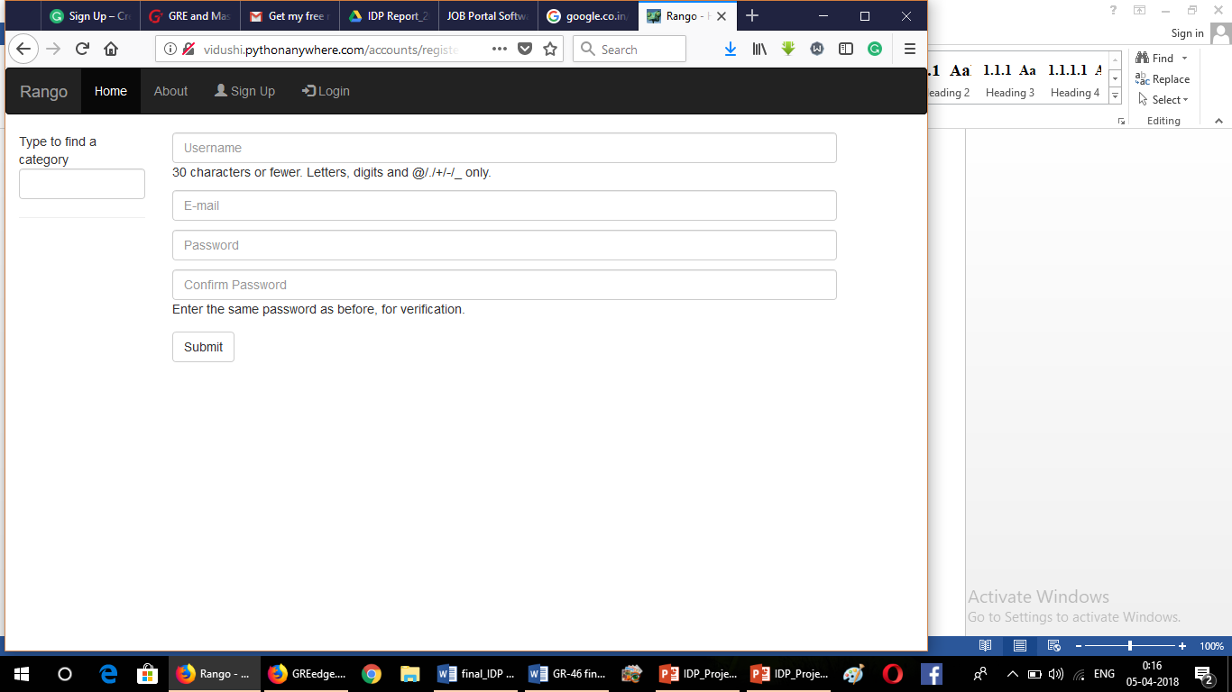

Figure 2.1 Rango’s Registration page

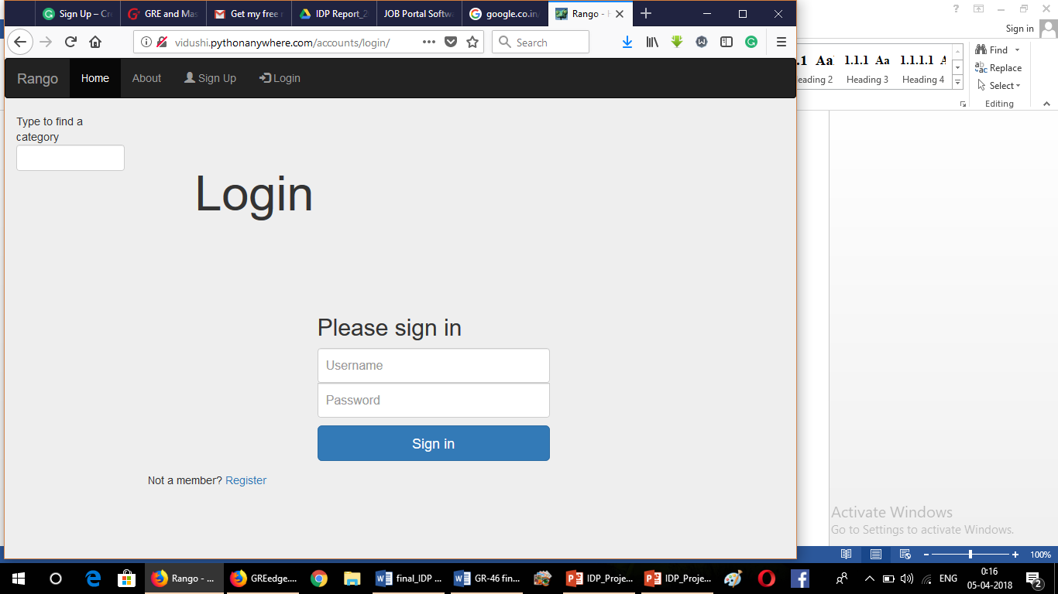

Figure 2.2 Login Page of Rango

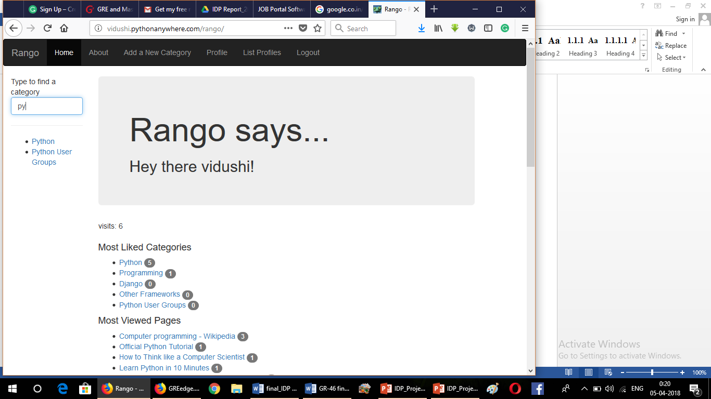

Figure 2.3 Home Page of Rango

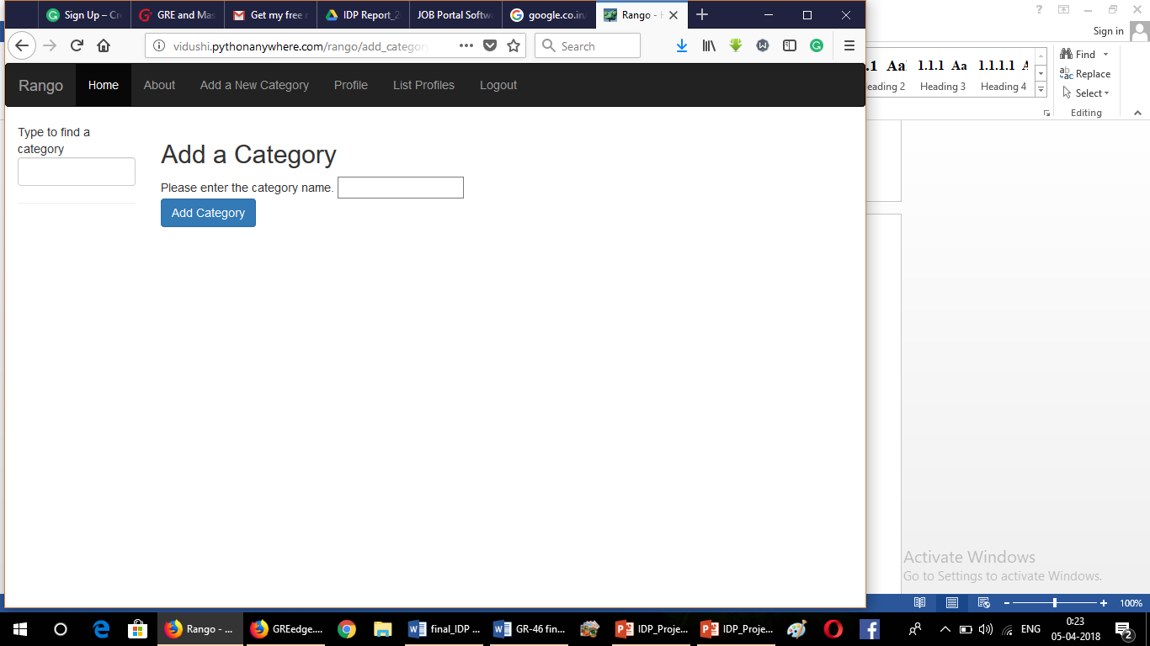

Figure 2.4 Add Category Page of Rango

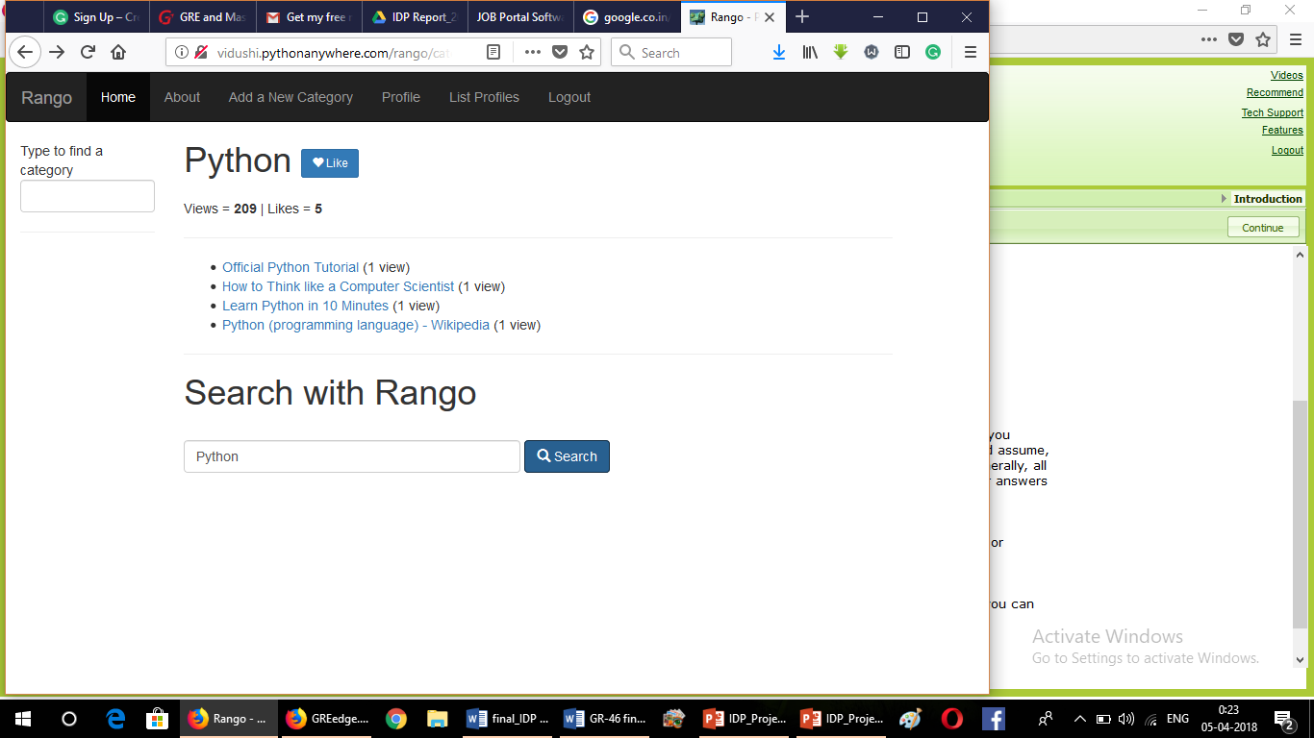

Figure 2.5 Python Category Page of Rango

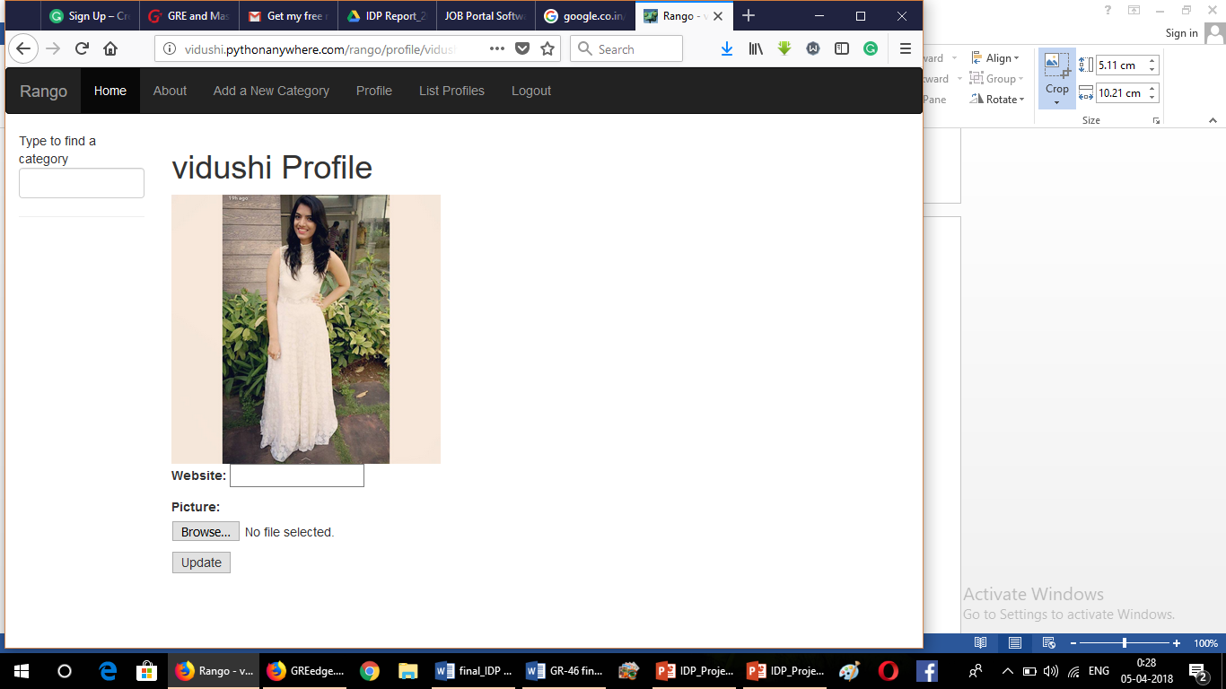

Figure 2.6 Profile Page of Rango

Later we were given our main project definition i.e. of Job Portal. We started working on it thereby.

Meanwhile we were working on the development of this project, were given opportunity to expand our technological knowledge.

We learnt Angular JS and Angular 5. Further we learned to merge Django and Angular. and using that learning we built a basic applications.

* ng5 (basic application to show simple CRUD Operations using only angular):
  1. <https://vidz1996.github.io/basic_app/>
  2. <https://karishmabardoliya.github.io/ng5/>

**Snapshots of ng5:**

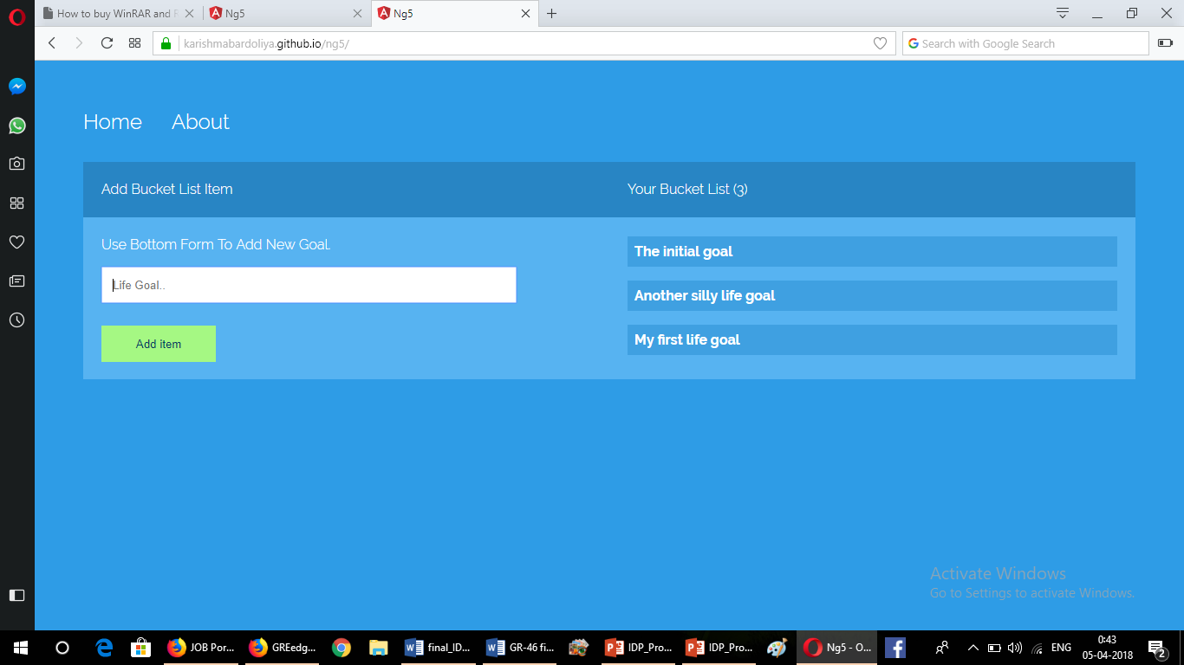

Figure 2.7 Home Page of ng5

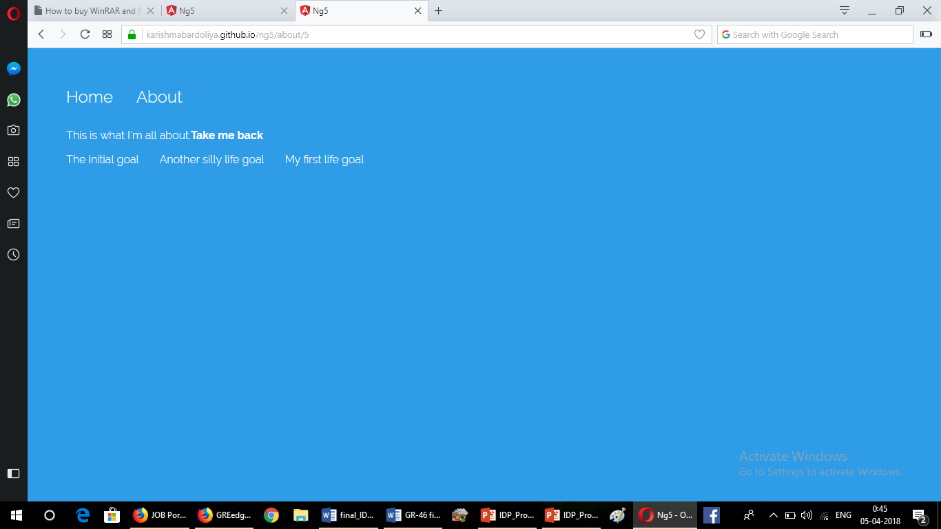

Figure 2.8 About Page of ng5

* angular_crud (CRUD operations with Django as backend):
  1. <https://dhruv-3d.github.io/CrudeAngular>
  2. <https://vidz1996.github.io/Angular_Demo2/>
  3. <https://karishmabardoliya.github.io/crud/>

**Snapshots of this app:**

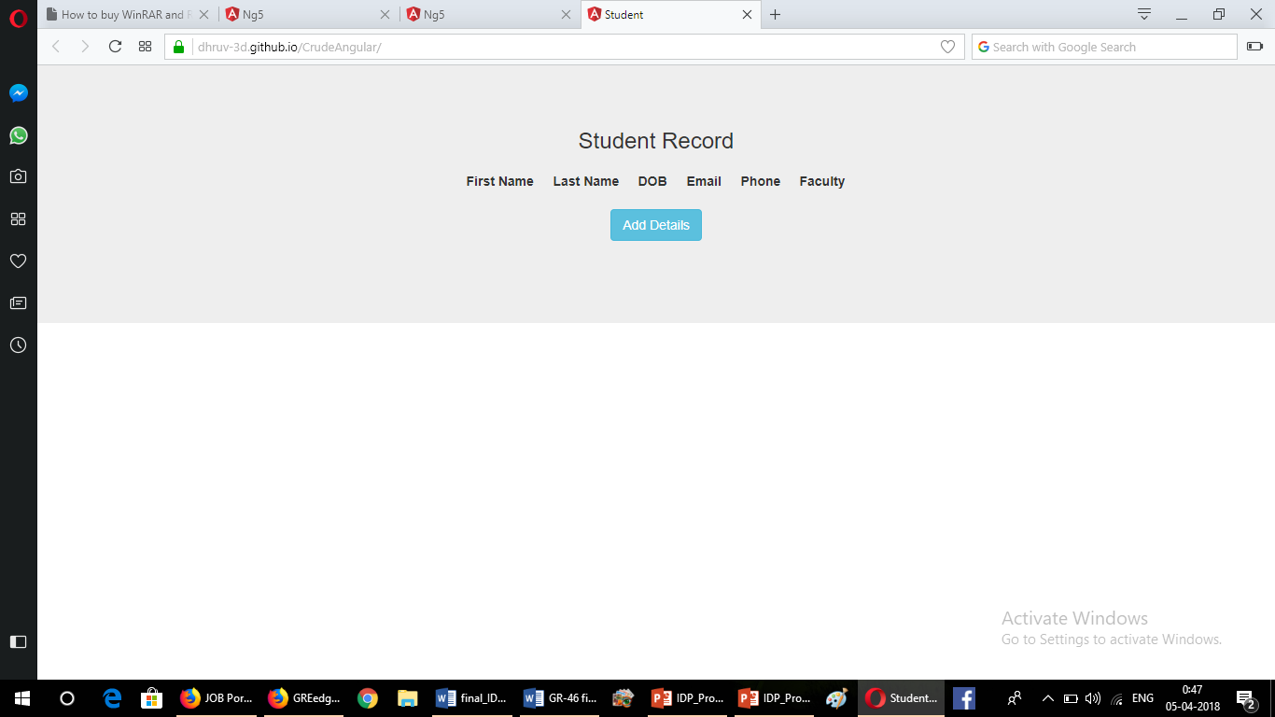

Figure 2.9 Index Page

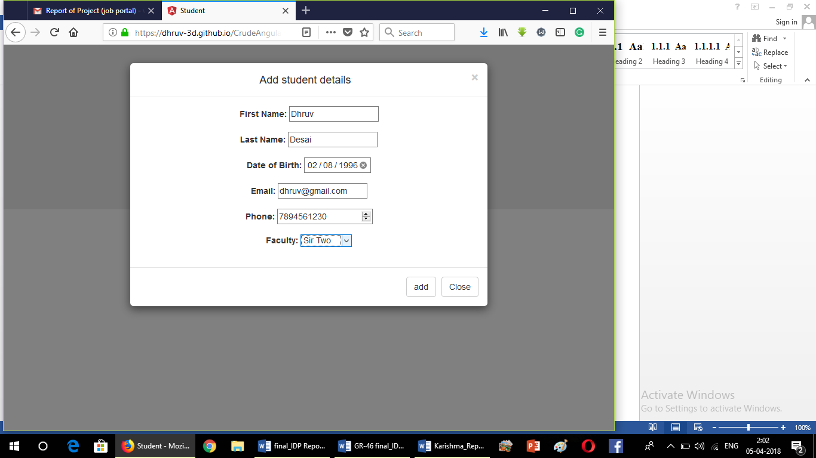

Figure 2.10 Add Details

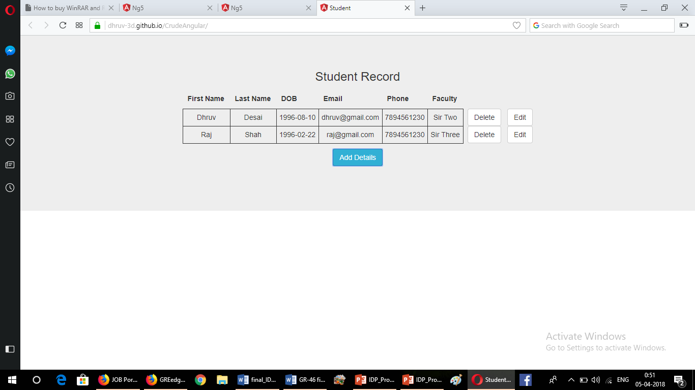

Figure 2.11 View Details

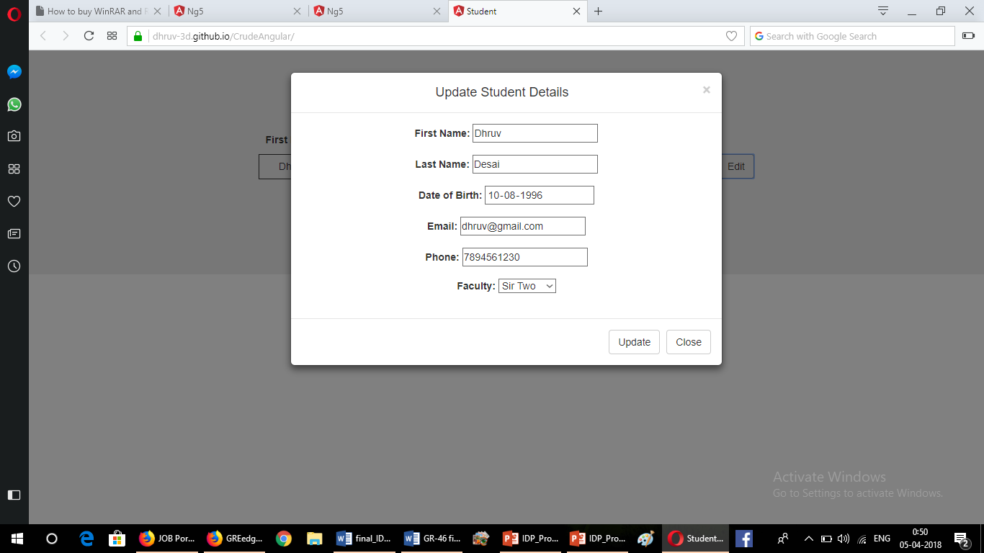

Figur 2.12 Update Details

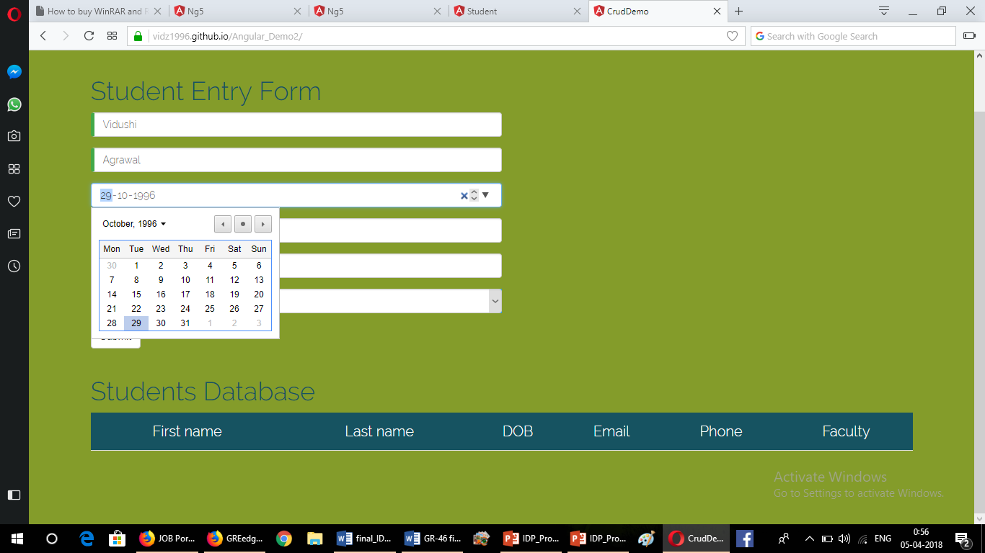

Figure 2.13 Add Details Form

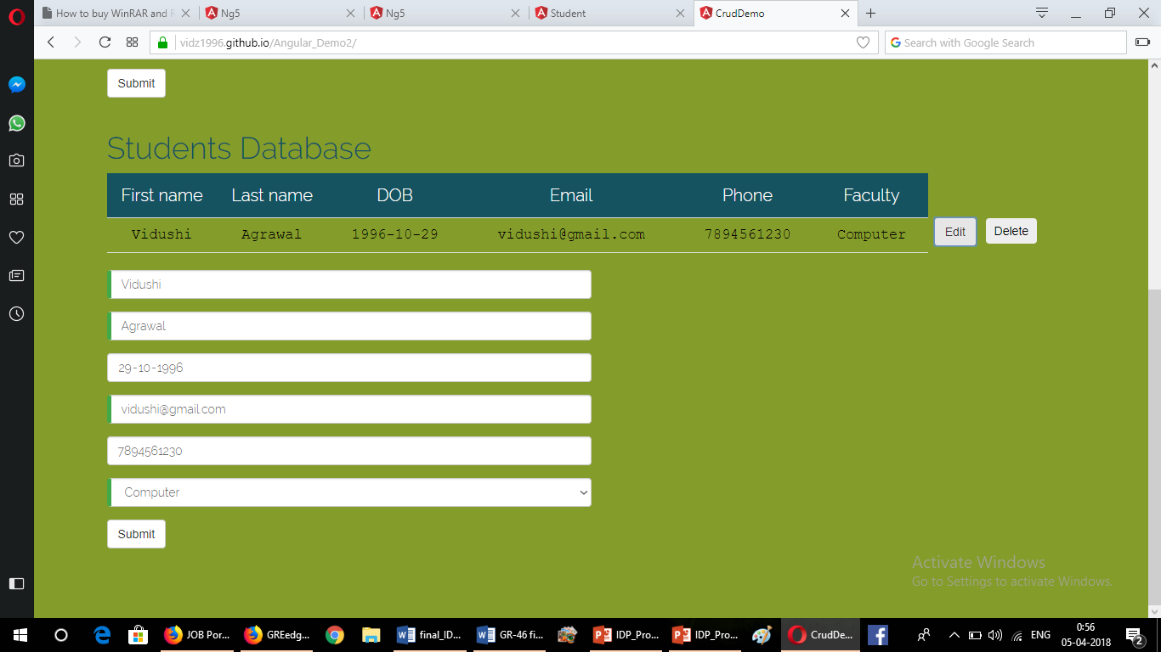

Figure 2.14 View and Update Details

Later we were assigned individual tasks:

* Vidushi learnt Django Rest Framework (DRF)
  + Integrate API into a project
  + Integrate Social Authentication like Google+ API and Facebook API.
* Karishma learnt Flask – Another Framework for Python Web Development
  + Built basic app with CRUD operations

Screeen Short:

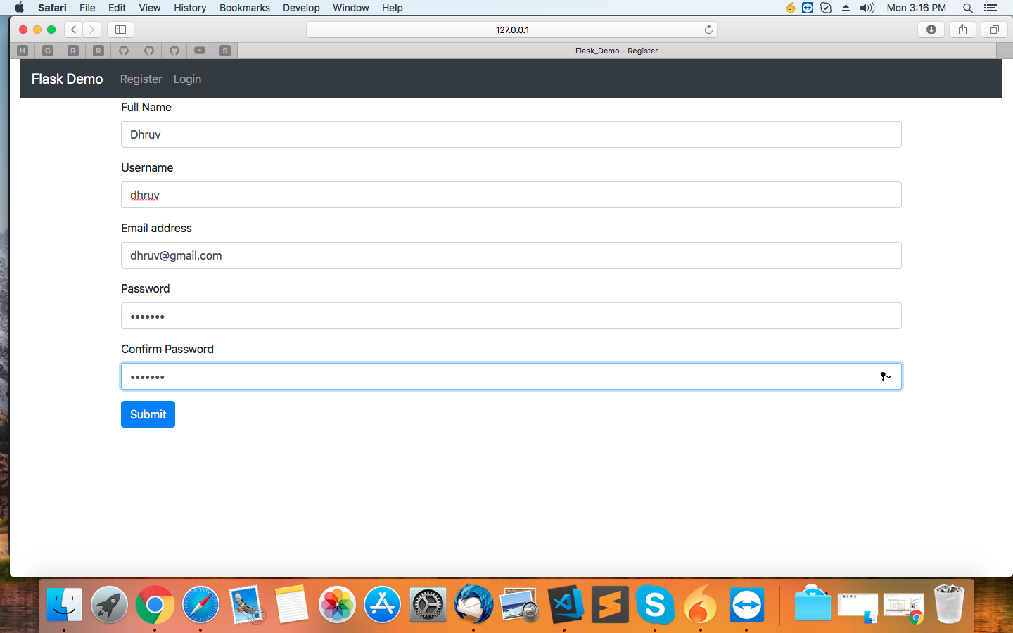

Figure 2.15 Registration Page of Flask Demo

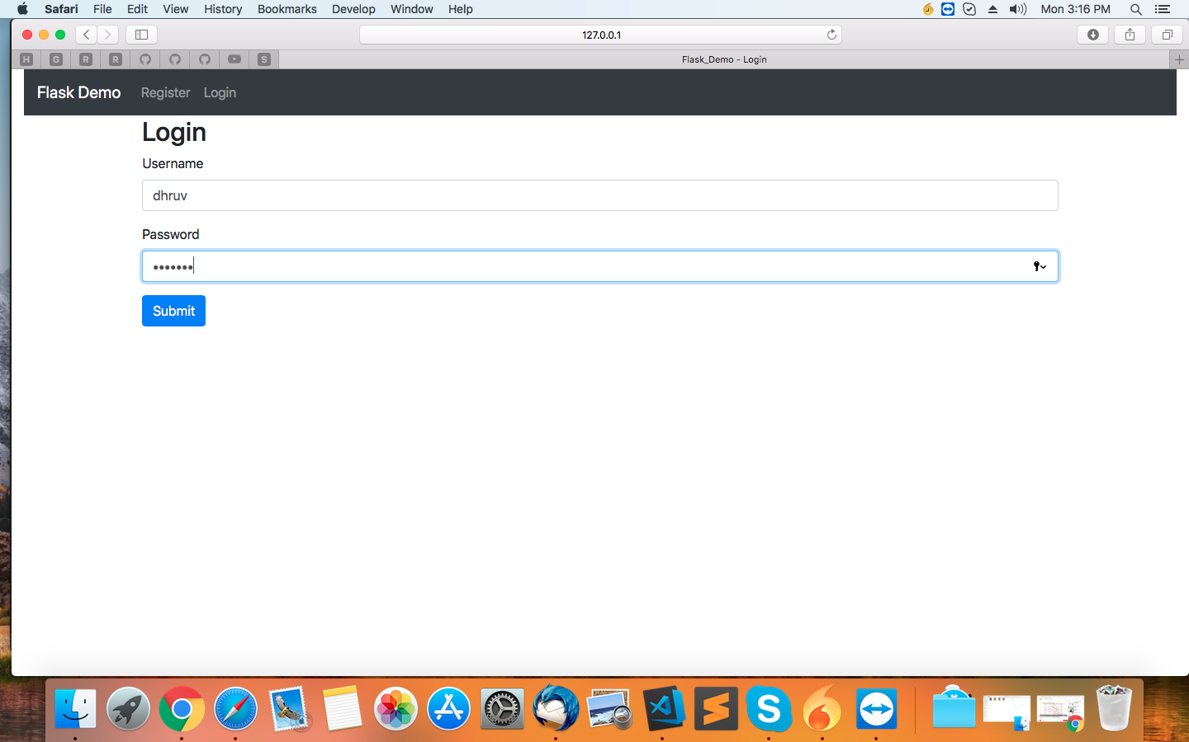

Figure 2.16 Login Page

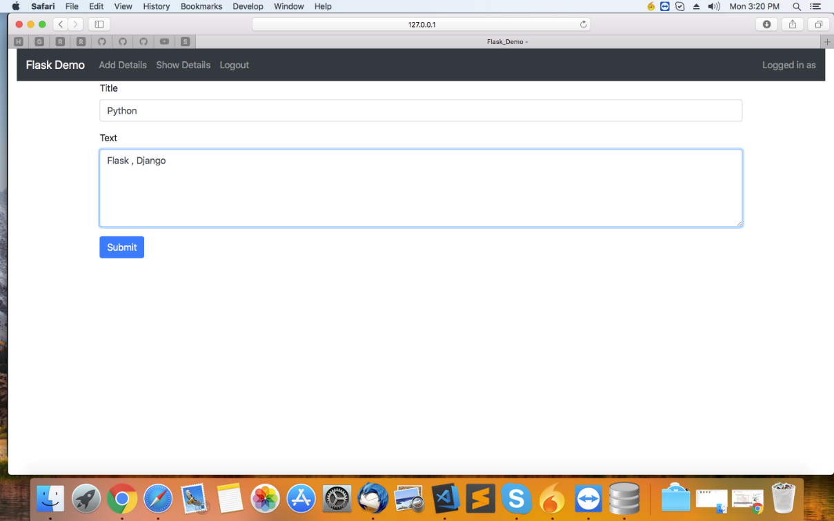

Figure 2.17 Add Detail page

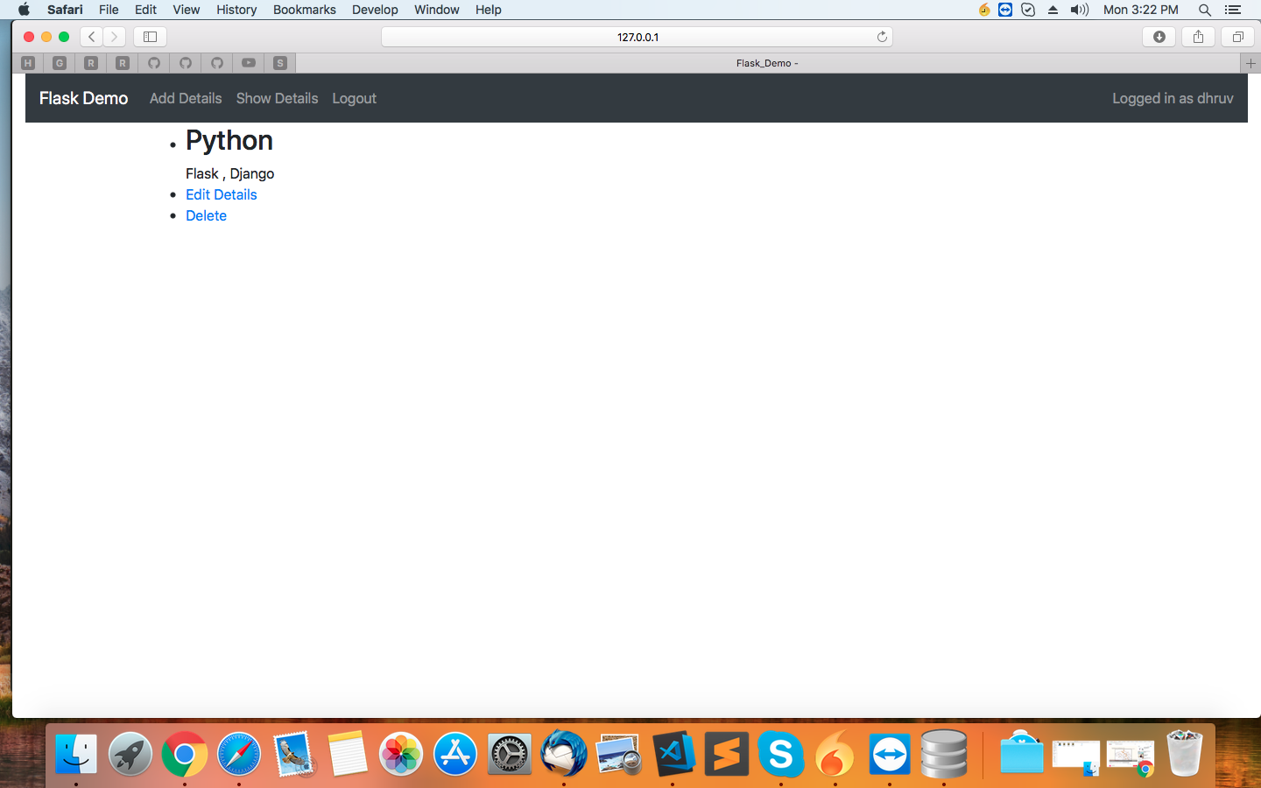

Figure 2.18 Show and Delete Details

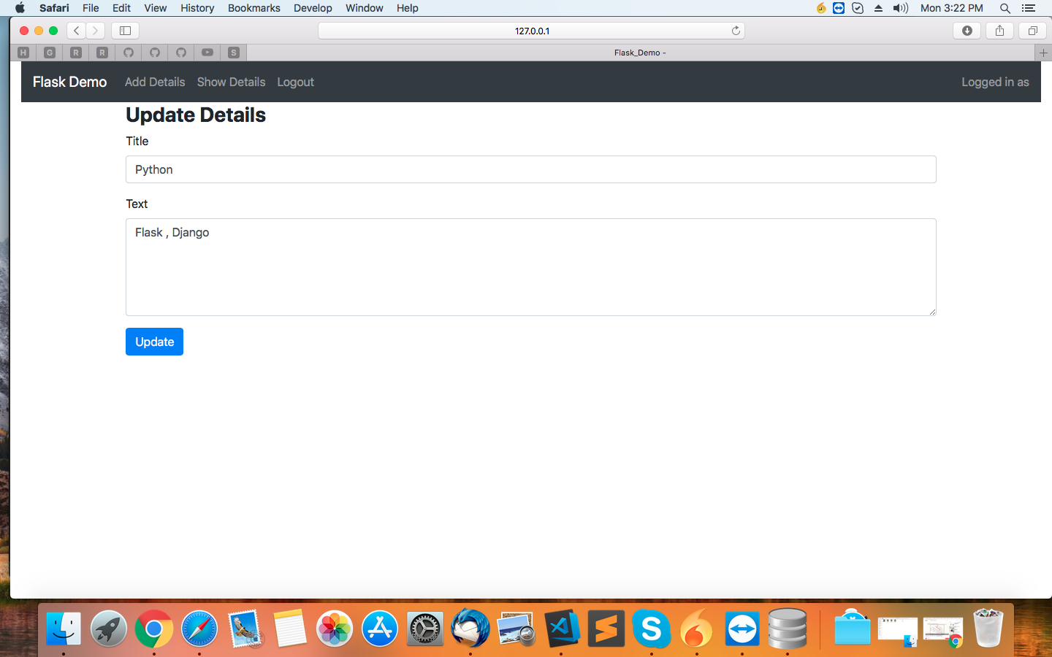

Figure 2.19 Show Update Details

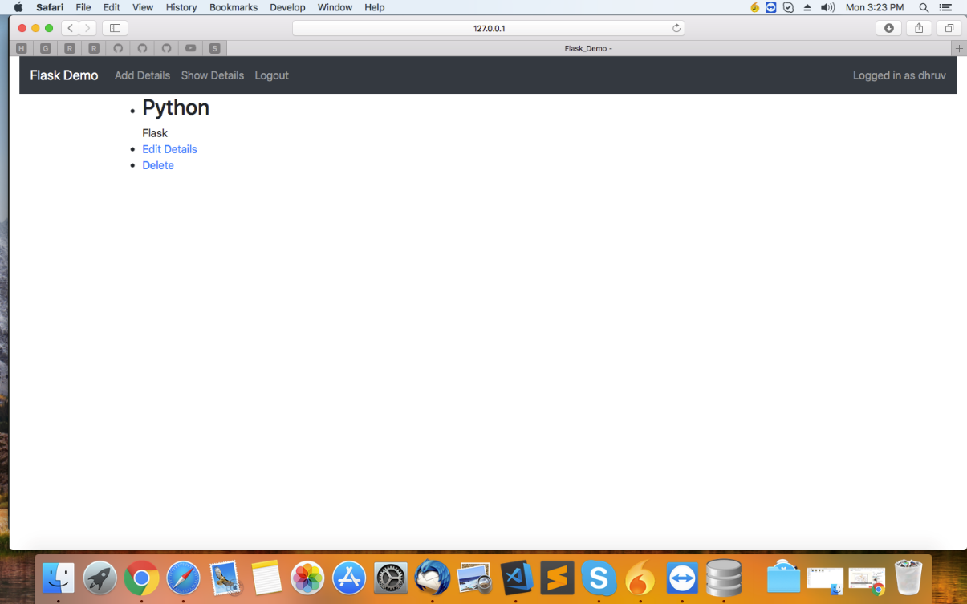

Figure 2.20 Updated Detail

* Dhruv learnt Grunt JS - A JavaScript task runner
  + A tool used to perform frequent tasks such as minification, compilation, unit testing, and linting.

Further our training continued and ended in this way:

* Vidushi and Karishma were told to start learning Machine Learning.
  + During this learning period we were put on to work on a client requirement:

***“Need to build a web app displaying live stock data of different stock markets.”***

Link to this app is: <http://clientapp.narola.online:8000/>

* + Later we were given one simple definition to build a classification model based on our learning in ML.

**“*Need to create a topic classifier just like this one from monkeylearn.***

* ***No interface needed (could be called by python console, not an API on the web)***
* ***No bow (bag of words)***

***Classify text according to a broad and generic topic tree.***[***https://app.monkeylearn.com/main/classifiers/cl_5icAVzKR/***](https://app.monkeylearn.com/main/classifiers/cl_5icAVzKR/) ***Looking for lower rates.***

***The topics are the same as the site on job description (monkeylearn).  
as corpus you can get wikipedia dataset.. i guess there are a lot of data  
eexampels to training model. The issue is wikipedia maybe do not fit.***

[***https://deeplearning4j.org/opendata***](https://deeplearning4j.org/opendata)

***or this one***

[***https://drive.google.com/drive/folders/0Bz8a_Dbh9Qhbfll6bVpmNUtUcFdjYmF2SEpmZUZUcVNiMUw1TWN6RDV3a0JHT3kxLVhVR2M***](https://drive.google.com/drive/folders/0Bz8a_Dbh9Qhbfll6bVpmNUtUcFdjYmF2SEpmZUZUcVNiMUw1TWN6RDV3a0JHT3kxLVhVR2M)

***or maybe using fb tool FastText***

[***https://github.com/facebookresearch/fastText***](https://github.com/facebookresearch/fastText) ***(similar to gensim)***

***for now i do not want any web interface.. just python console  
further i will use on other pieces of the project”***

* Dhruv was put on to work with TL on a live project called **“Driven”** platform.

**Introduction to Driven Platform:-**

Driven is an innovative solution enabling competitive costing for automotive (re)insurance professionals that offers

* An unparalleled view of factors driving automotive losses via validated, curated and up-to-date external data
* Benchmark insights, data-driven comparative risk assessment and selection.

The project runs on Django as back-end and Google Closure Library as front-end.

Dhruv has worked on following modules of Driven platform.

1. Generating GeoMaps (national & regional wise)
2. Data visualization using Google Charts
3. Saving the generated plots

* **Snapshots of Driven Platform**

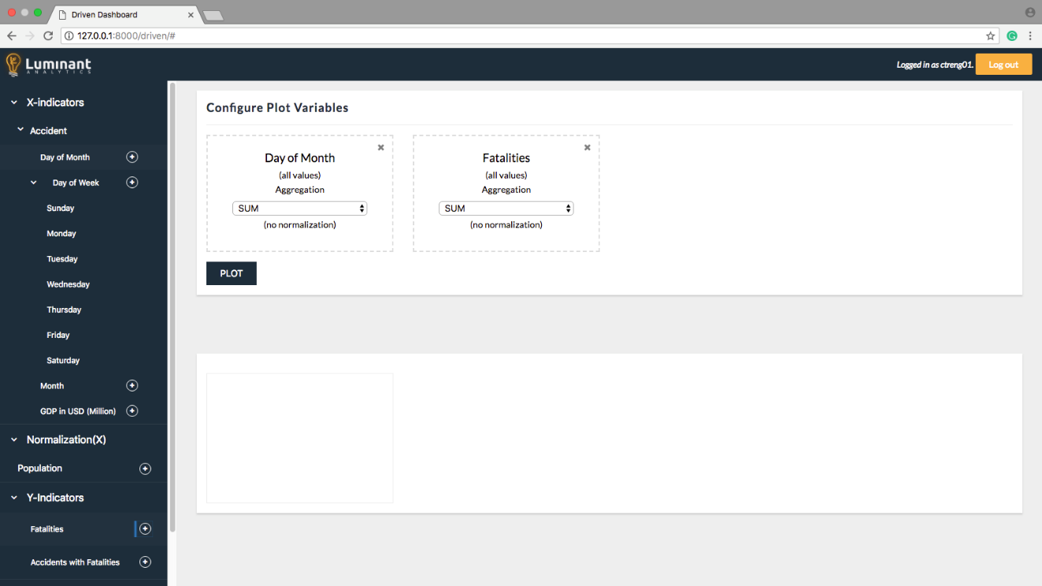

Figure 2.21 Driven Dashboard

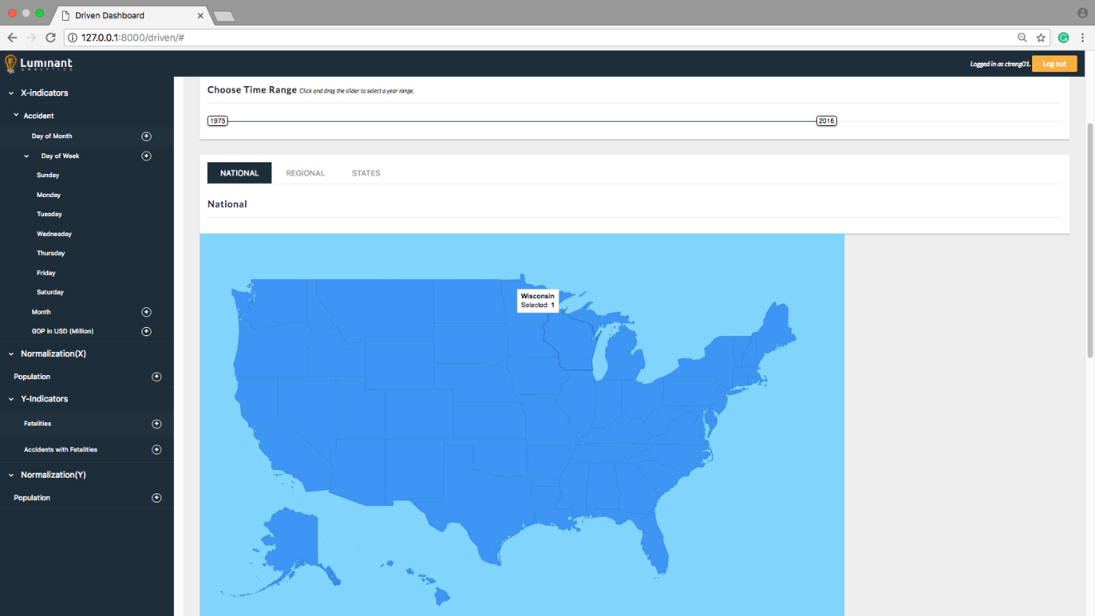

Figure 2.22 US National Map

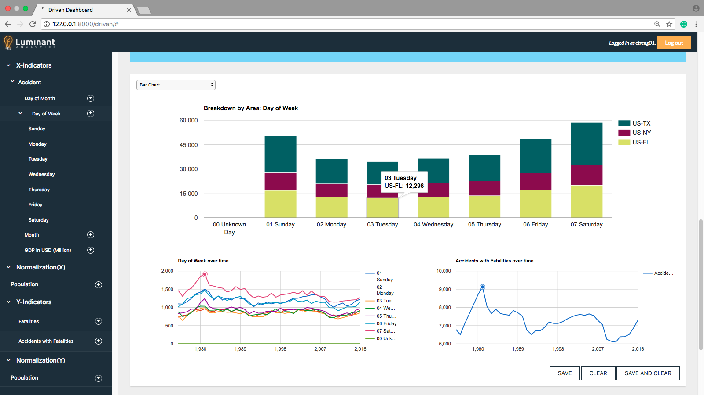

Figure 2.23 Charts generated on selecting states

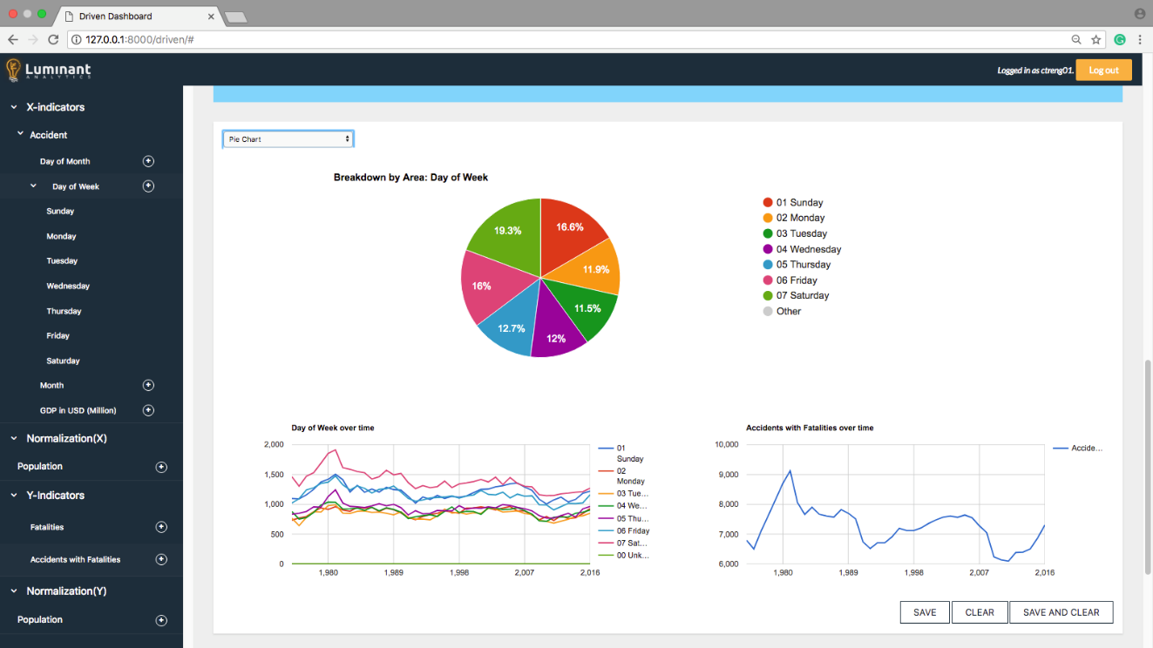

Figure 2.24 Pie Chart Represenatation

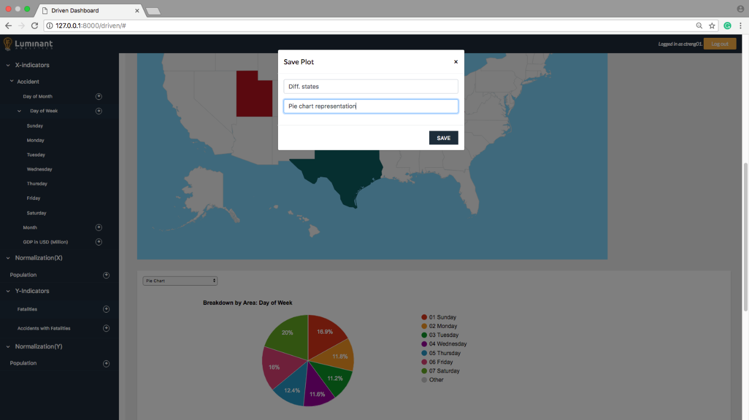

Figure 2.25 Saving of generated plots

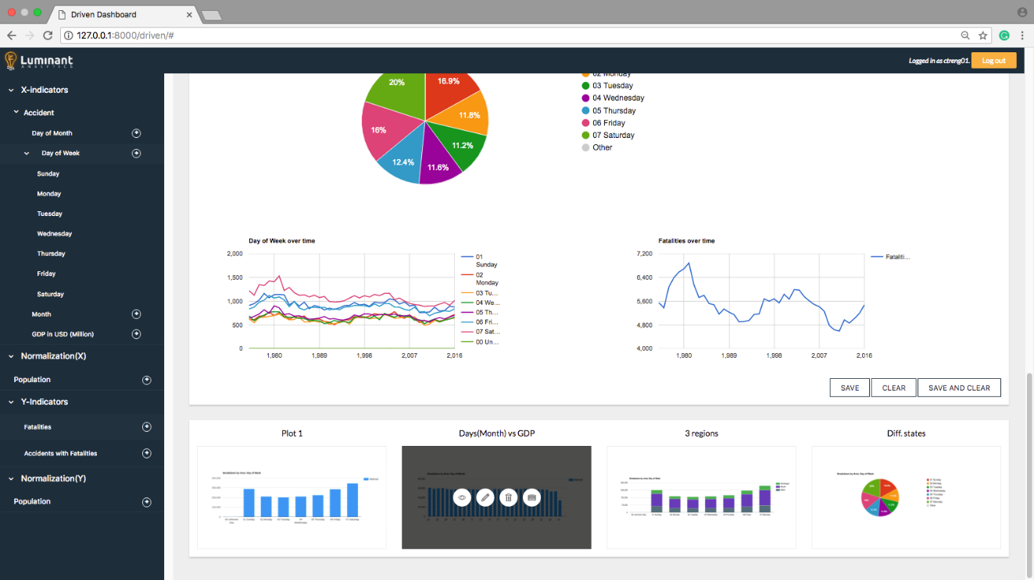

Figure 2.26 Lowe Panel with saved plots

# System Planning

## Project Development Approach

Each project need to be developed with software model which makes the project with high quality, reliable and cost effective.

### Software Model

Iterative incremental model was adapted for the Job Portal project. Iterative process starts with a simple implementation of a subset of the software requirements and iteratively enhances the evolving versions until the full system is implemented. At each iteration, design modifications are made and new functional capabilities are added. In this incremental model, the whole requirement is divided into various builds.

During each iteration, the development module goes through the requirements, design, implementation and testing phases. So as for the Job Portal project, the requirements were divided into various builds as jobseeker, employer, job and admin modules. The advantage of this approach is that each modules had undergone the iterative and incremental approach at the same time so that parallel developing could be made possible with this life cycle model. Testing and debugging is easier and to add some functionality or modify some of the functionalities or requirements are easy.

## System Modules

Overhere, briefly explain modules of your project. And also explain their role.

### *Admin*

Admin manages and controls the whole web application. The major roles of Admin are:

1. Manage Job Seeker and Employer Profiles
2. Provide Roles and Authentication to Users
3. Manage posted Jobs
4. Can also change some of the templates.

### *Employer*

Employer is a designated person of a company who is looking for a employee regarding a particular job role. The major role of an Employer is to post jobs with detailed job description (job title, company name, job type, description, required qualification, etc.)

### *Job Seeker*

Job Seeker is the one who is looking for an aspiring and relevant job. The major role of a Job Seeker is that he/she can search jobs here and apply for them if they find relevant.

## Functional Requirements

Table . Functional requirements for Job Portal

|  |  |
| --- | --- |
| **ID** | **Title and Description** |
| **FR1** | **Login Control**  User is restricted to some features which are only available when the users log in. |
| **FR2** | **Search Job**  Jobseeker can search job by category and subcategory of different fields |
| **FR3** | **Search Jobseeker**  Employer can search jobseeker by category, subcategory, state or city. |
| **FR4** | **Save Jobseeker**  Employer can save jobseeker. |
| **FR5** | **Email Verification**  User needs to be verified with their email. |
| **FR6** | **Apply for Job**  Jobseekers can apply for job posted by employer. |
| **FR7** | **Upload Resume**  Jobseekers can upload and update their resumes on the portal. |
| **FR8** | **Job Approval**  Employer can approve/reject the job applicatons by jobseekers on the jobs they have posted. |

## Non Functional Requirements

1. Secure access of confidential data (user’s details). SSL can be used
2. 24 X 7 availability.
3. Better component design to get better performance at peak time.
4. Flexible service based architecture will be highly desirable for future extension.

## Timeline Chart

|  |  |  |  |  |  |
| --- | --- | --- | --- | --- | --- |
| **ACTIVITY** | **25 JAN-31 JAN** | **1 FEB-14 FEB** | **15 FEB-28 FEB** | **1 MAR-20 MAR** | **21 MARCH-4 APARIL** |
| **Requirement Analysis** |  |  |  |  |  |
| **Designing** |  |  |  |  |  |
| **Implementation** |  |  |  |  |  |
| **Testing** |  |  |  |  |  |
| **Report Generation** |  |  |  |  |  |

Figure . Timeline Chart for Job Portal

# System Design

## Use Case Diagram

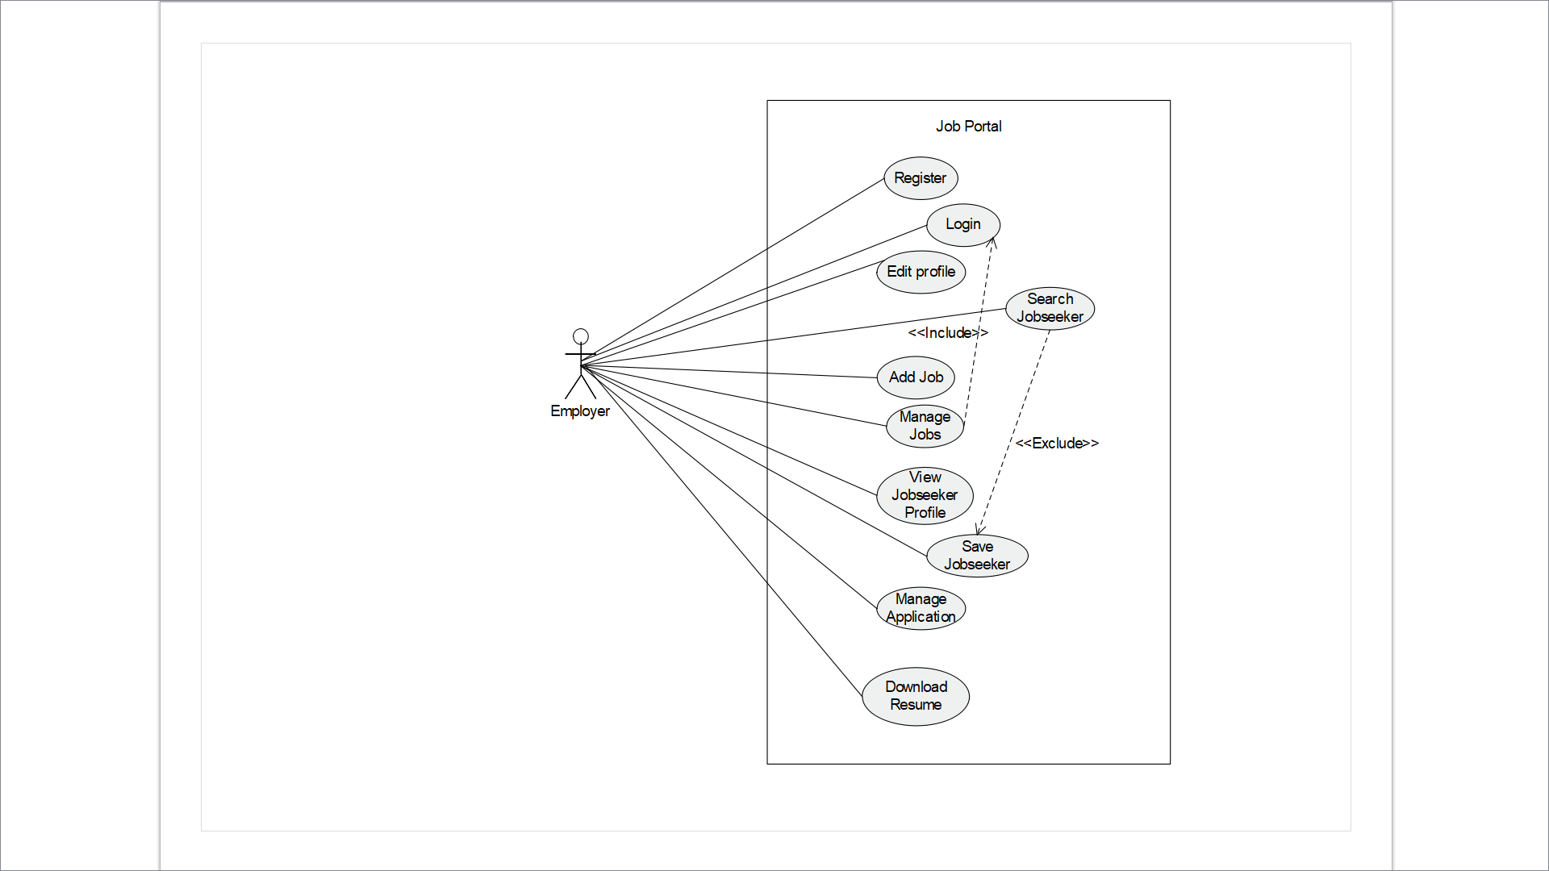

Figure . Use case of Employer

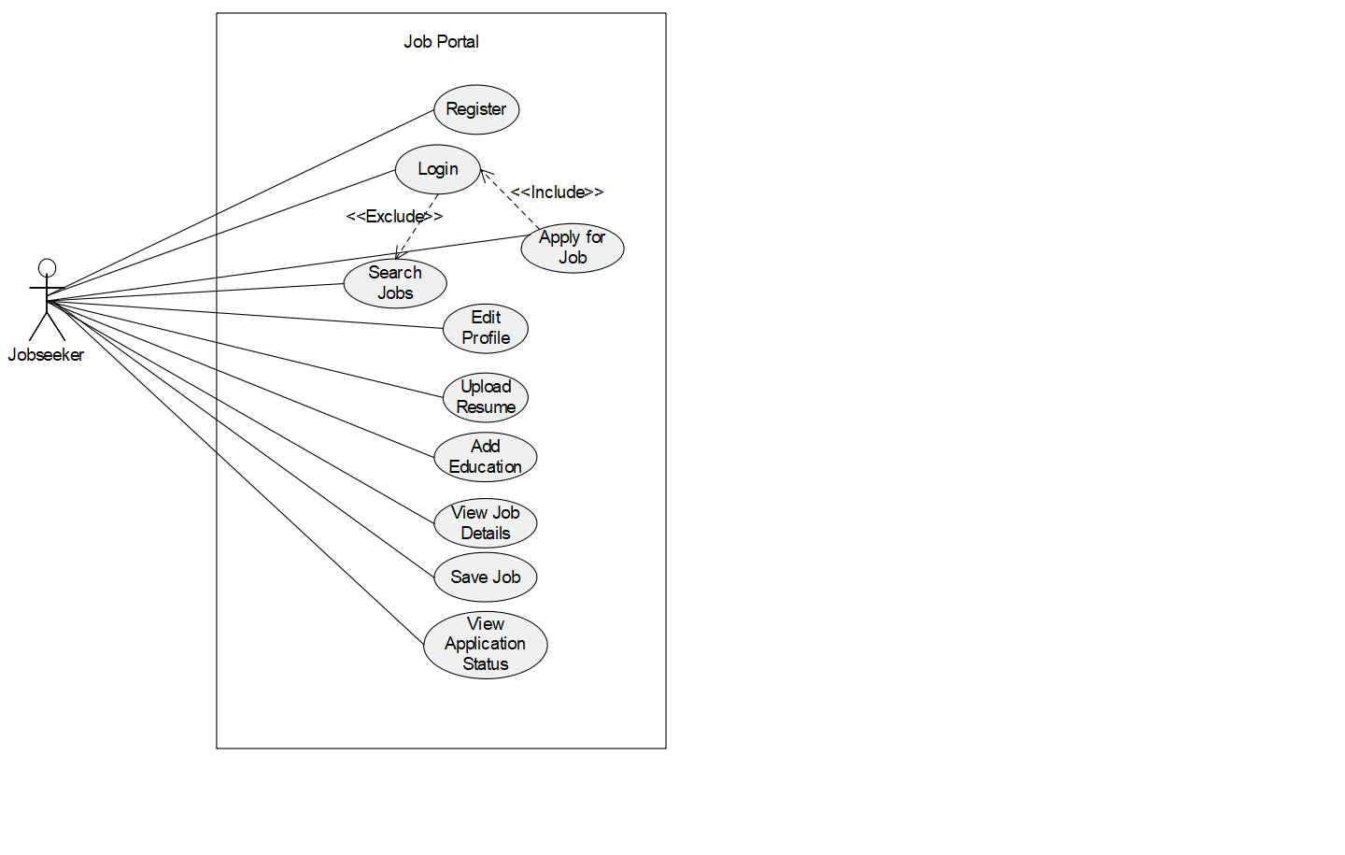

Figure . Use case of Jobseeker

## Sequence Diagram

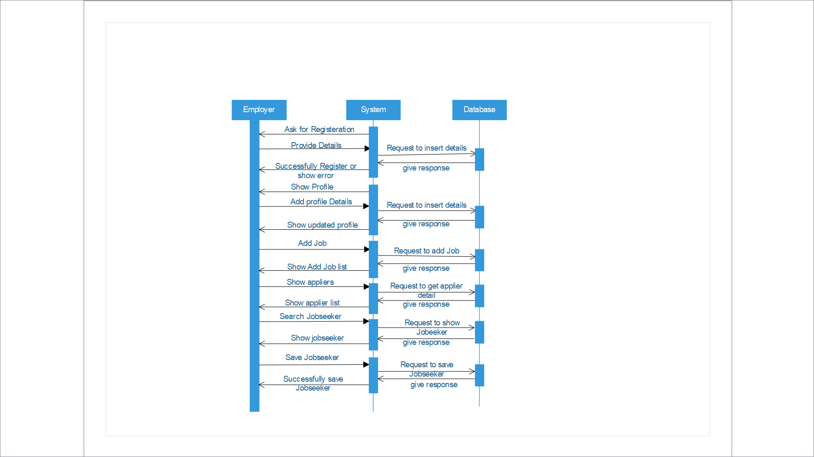

Figure . Sequence of Employer

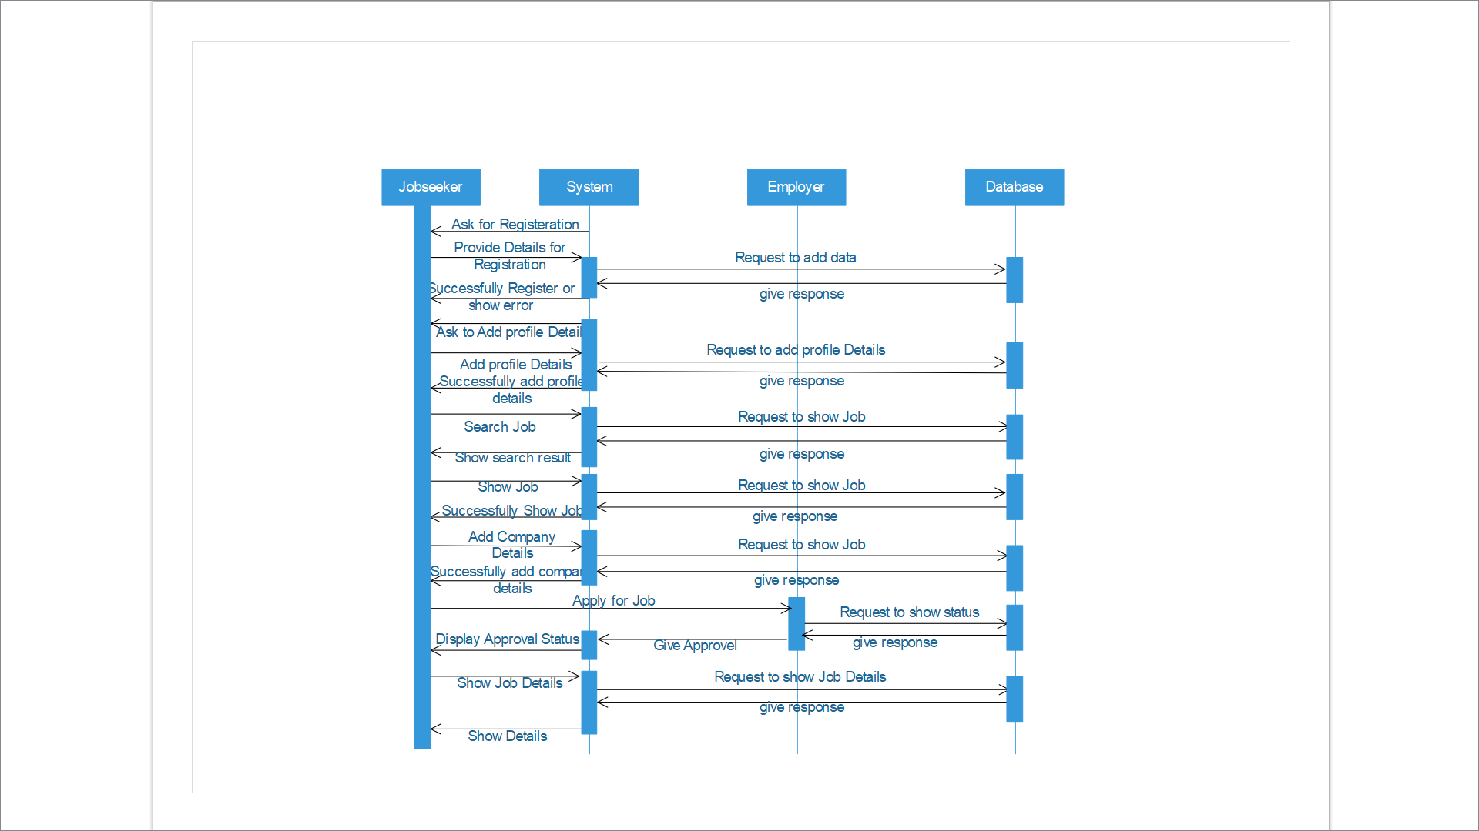

Figure . Sequence of Jobseeker

## Activity Diagram

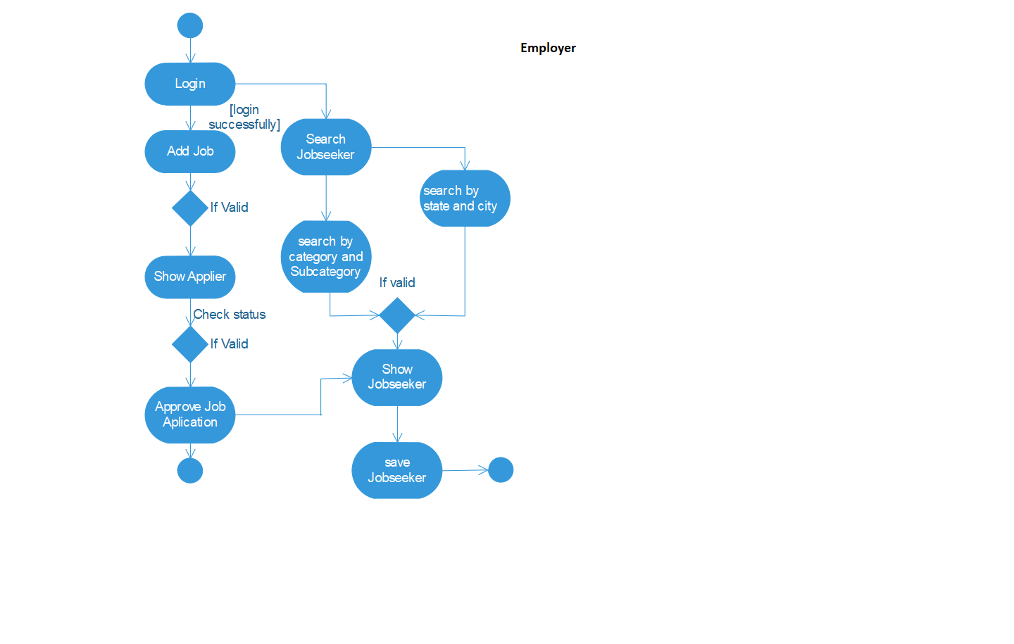

Figure . Activity of Employer

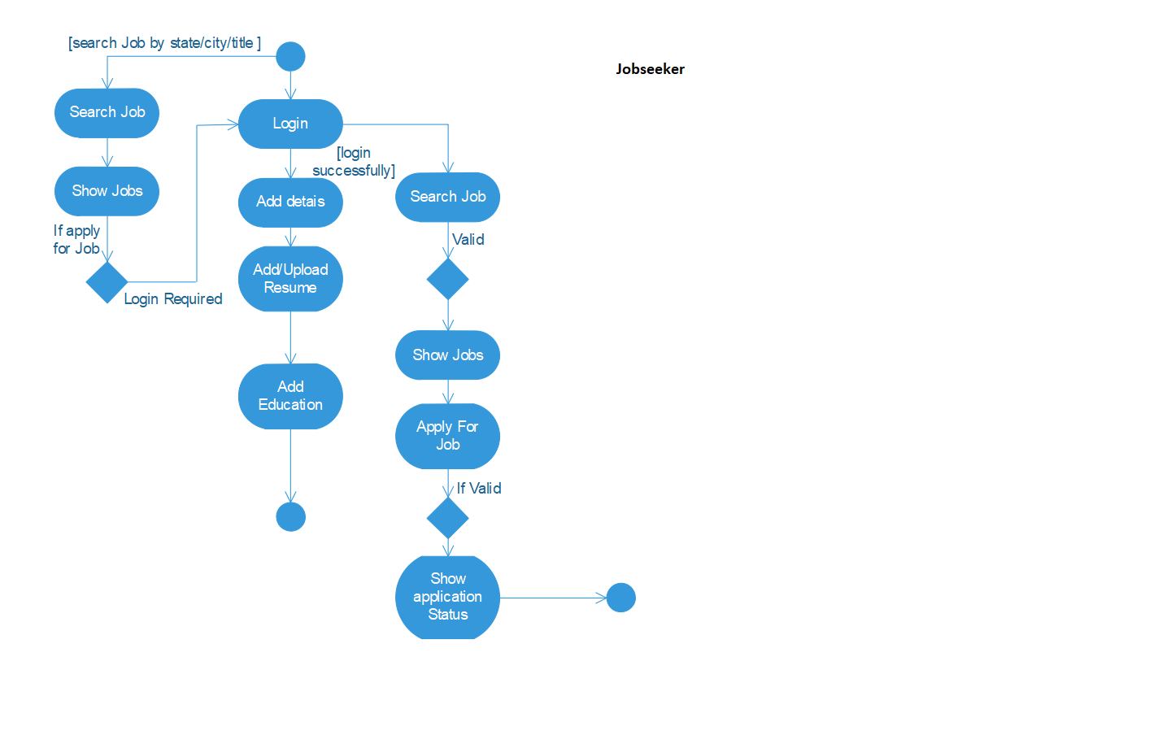

Figure . Activity of Jobseeker

## Class Diagram

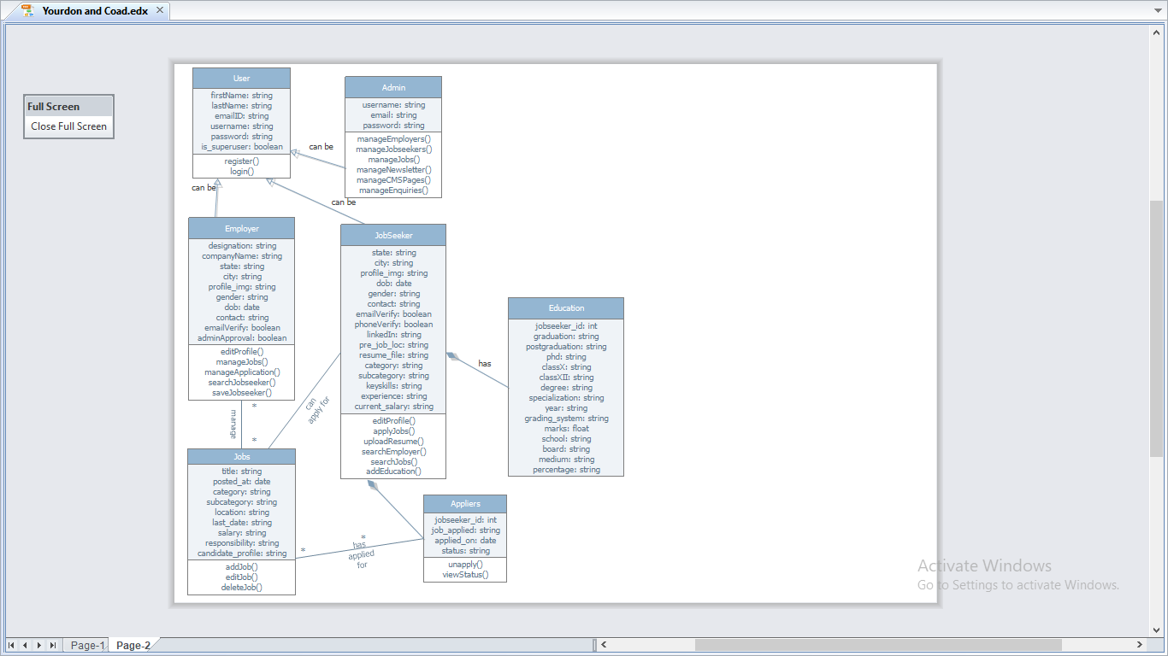

Figure . Class Diagram

## Database Schema

Table . User Table

|  |  |  |  |  |
| --- | --- | --- | --- | --- |
| Column Name | Data Type | Size | Constraint | Description |
| Id | INT | 5 | Primary Key Auto Increment | ID No. |
| username | VARCHAR | 150 | Not Null, Unique | Jobseeker_name |
| Password | VARCHAR | 128 | Not Null | Password |
| email | VARCHAR | 254 | ---- | Email ID |
| First_name | VARCHAR | 30 | ---- | First name |
| Last_name | VARCHAR | 30 | ---- | Last name |

Table . Employer Table

|  |  |  |  |  |
| --- | --- | --- | --- | --- |
| Column Name | Data Type | Size | Constraint | Description |
| Id | INT | 5 | Primary Key, Auto Increment | ID No. |
| profile_img | VARCHAR | 100 | Not Null | Profile Image |
| gender | VARCHAR | 10 | Not Null | Gender |
| dob | DATE | 50 | Not Null | DOB |
| contact_no | INT Unsigned | 50 | Not Null | Contact No. |
| state | VARCHAR | 50 | --- | State |
| city | VARCHAR | 50 | Not Null | City |
| company | VARCHAR | 150 | Not Null | Company |
| designation | VARCHAR | 30 | Not Null | Designation |
| user_id | INT | - | Foreign Key - User(id) | User registered as Employer |

Table . Jobseeker Table

|  |  |  |  |  |
| --- | --- | --- | --- | --- |
| Column Name | Data Type | Size | Constraint | Description |
| Id | INT | 5 | Primary Key, Auto Increment | ID No. |
| profile_img | VARCHAR | 100 | Not Null | Profile Image |
| gender | VARCHAR | 10 | Not Null | Gender |
| dob | DATE | 50 | Not Null | DOB |
| contact_no | INT Unsigned | 50 | Not Null | Contact No. |
| state | VARCHAR | 50 | --- | State |
| city | VARCHAR | 50 | Not Null | City |
| user_id | INT | - | Foreign Key – User(id) | User registered as Jobseeker |

Table . Jobseeker Profile Table

|  |  |  |  |  |
| --- | --- | --- | --- | --- |
| Column Name | Data Type | Size | Constraint | Description |
| Id | INT | 5 | Primary Key | ID No. |
| linked_In | VARCHAR | 100 | Not Null | LinkedIn Profile |
| pref_job_loc | VARCHAR | 200 | Not Null | Preferred Job Locations |
| resume | VARCHAR | - | Not Null | Uploaded Resume |
| category | VARCHAR | 100 | Not Null | Category/Industry |
| subcategory | VARCHAR | 100 | Not Null | Subcategory/Field |
| keyskills | TEXT | - | Not Null | Keyskills |
| experience | VARCHAR | 50 | Not Null | Experience |
| current_salary | VARCHAR | 100 | --- | Current Salary |
| jobseeker_id | INT | - | Foreign Key – Jobseeker(id) | Job Seeker |

Table . Education Table

|  |  |  |  |  |
| --- | --- | --- | --- | --- |
| Column Name | Data Type | Size | Constraint | Description |
| Id | INT | 5 | Primary Key,Auto Increment | ID No. |
| category | VARCHAR | 30 | --- | Category |
| specialization | VARCHAR | 50 | Not Null | Specialization |
| university | VARCHAR | 20 | Not Null | University |
| year | VARCHAR | 10 | Not Null | Year |
| grading_system | VARCHAR | 50 | Not Null | Grading System |
| marks | DECIMAL | - | Not Null | Marks |
| school | VARCHAR | 20 | Not Null | School |
| board | VARCHAR | 10 | Not Null | Board |
| medium | VARCHAR | 20 | Not Null | Medium |
| percentage | DECIMAL | - | Not Null | Percentage |
| jobseeker_id | INT | - | Foreig Key – Jobseeker(id) | Job Seeker |

Table . Add_Job Table

|  |  |  |  |  |
| --- | --- | --- | --- | --- |
| Column Name | Data Type | Size | Constraint | Description |
| Id | INT | 5 | Primary Key | ID No. |
| title | VARCHAR | 100 | Not Null, Unique | Job Title |
| category | VARCHAR | 100 | Not Null | Category/Industry |
| subcategory | VARCHAR | 100 | Not Null | Subcategory of category |
| last_date | DATE | - | Not Null | Last Date to apply |
| responsibility | TEXT | - | Not Null | Job Responsibility |
| candidate_profile | TEXT | - | Not Null | Candidate Profile |
| salary | VARCHAR | 50 | Not Null | Salary to be given |
| posted_date | DATETIME | - | Not Null | Job Posted on |
| slug | VARCHAR | 50 | Not Null, Unique | Slug of Job Title |
| employer_id | INT | - | Foreign Key – Employer(id) | Employer who posted this job |

Table . Appliers Table

|  |  |  |  |  |
| --- | --- | --- | --- | --- |
| Column Name | Data Type | Size | Constraint | Description |
| Id | INT | 5 | Primary Key, Auto Increment | ID No. |
| date_apply | DATE | - | Not Null | Date applied on |
| status | VARCHAR | 50 | Not Null | Status of the Applier |
| job_id | INT | - | Foreign Key – AddJob(id) | Job applied for |
| jobseeker_id | INT | - | Foreign Key – Jobseeker(id) | Jobseeker who applied |

## Data Flow Diagram

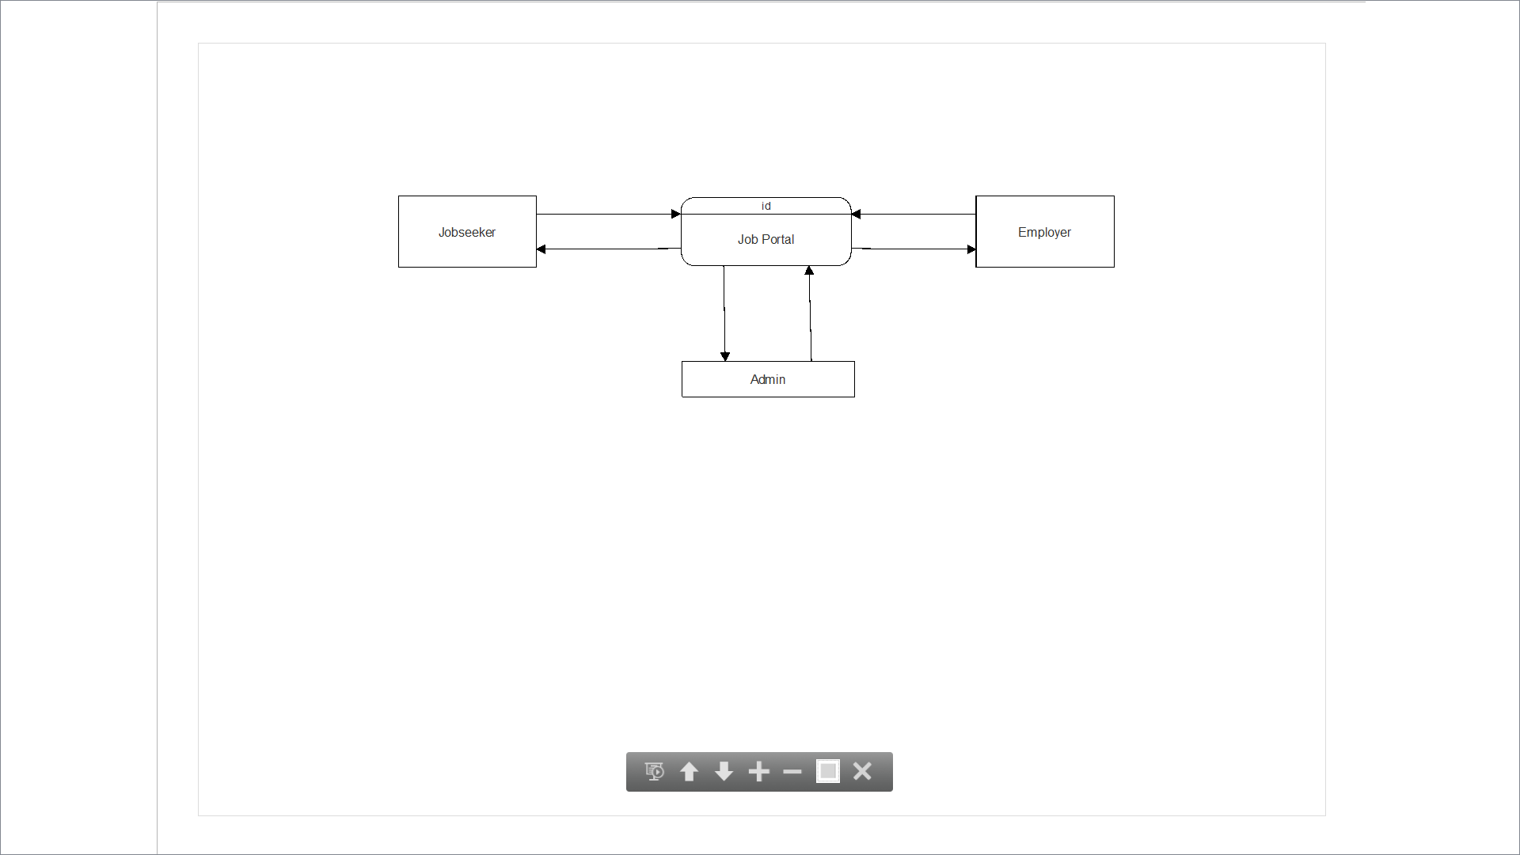

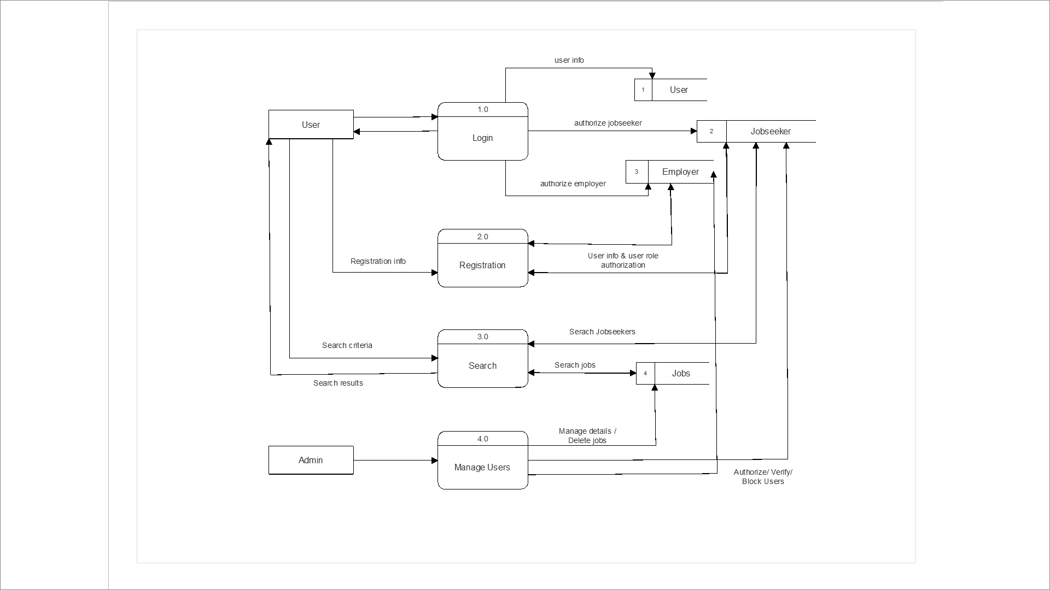Figure . DFD - Context level diagram (Level 0)

Figure . DFD - Level 1

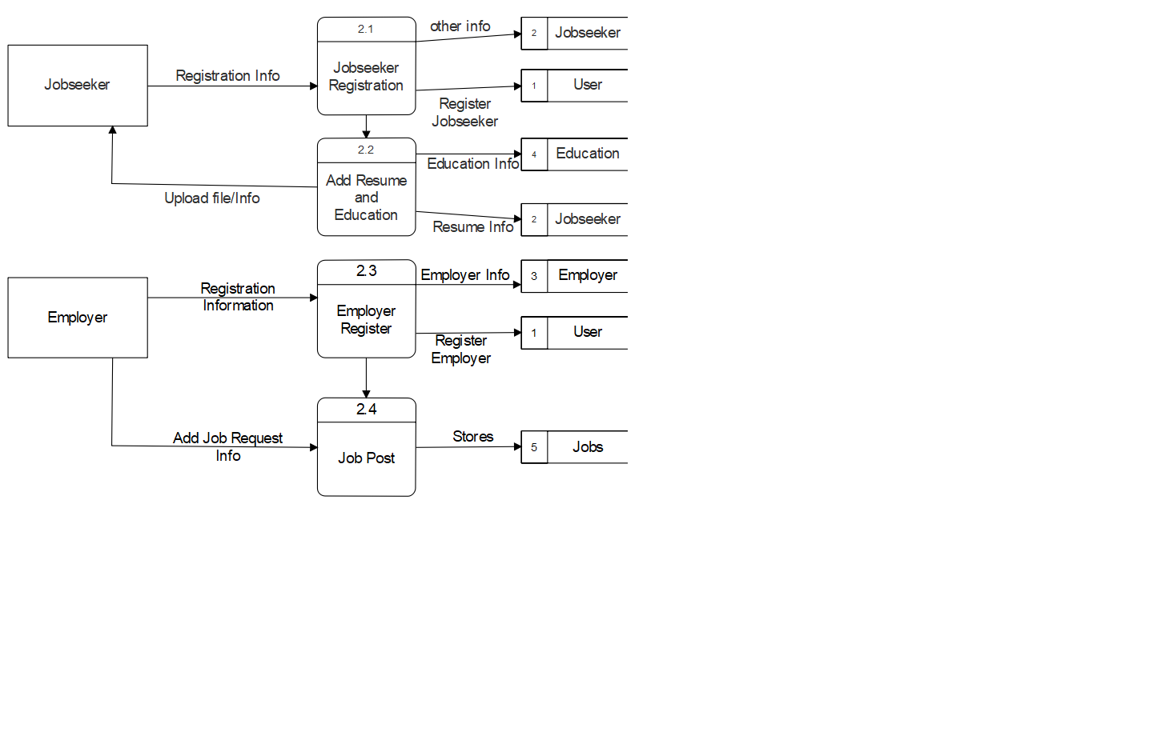

Figure . DFD - Level 2(user)

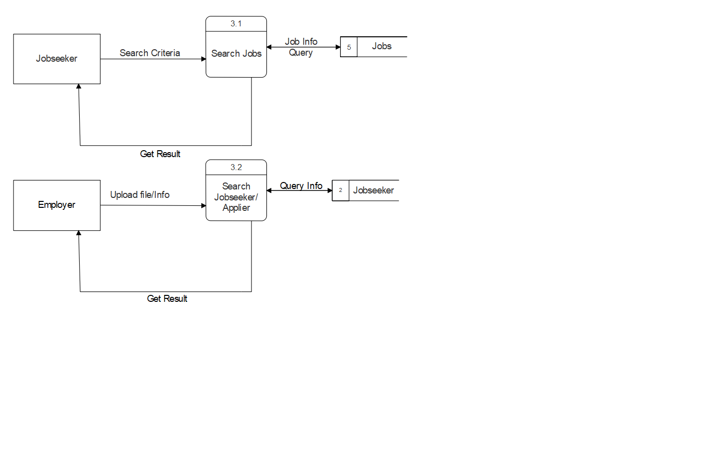

Figure . DFD - Level 2(search)

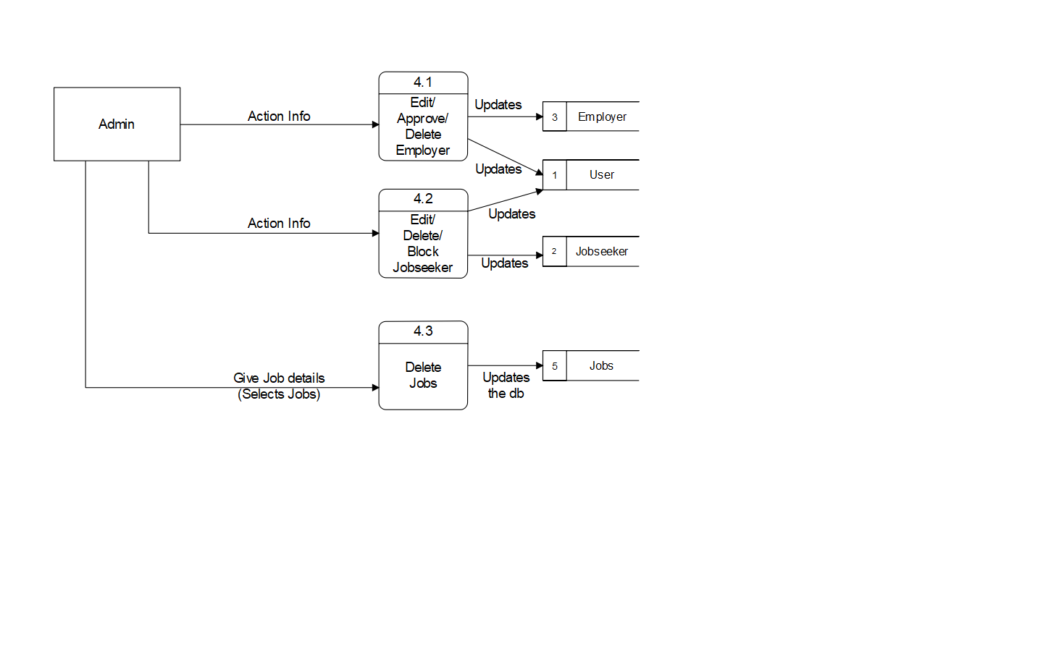

Figure . DFD - Level 2(Admin)

## ER Diagram

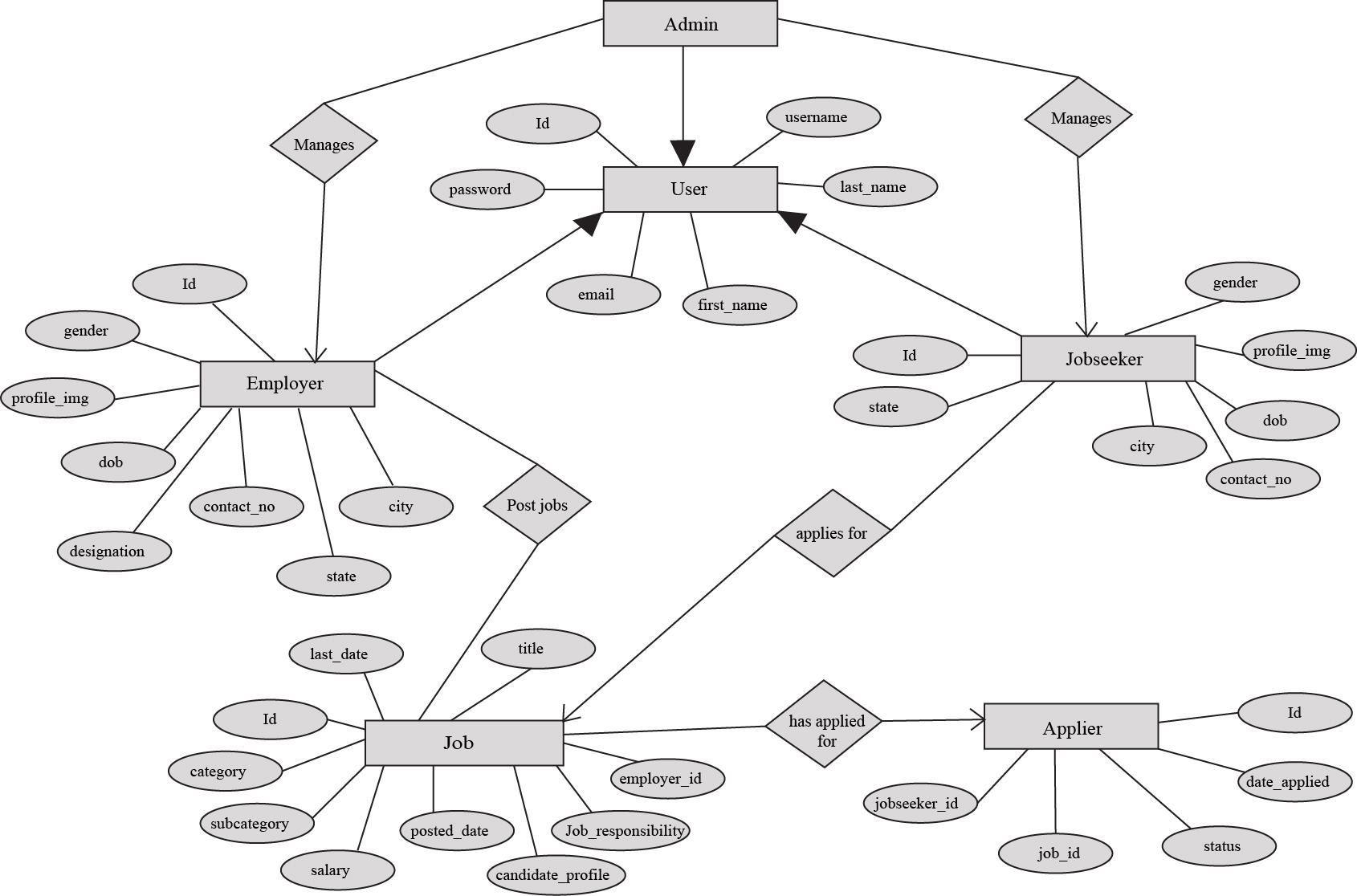

Figure . ER Diagram

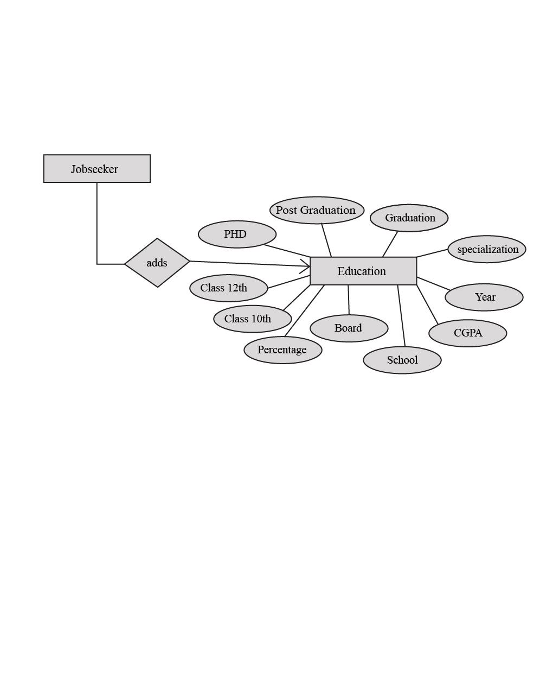

Figure . ER Diagram (cont.)

# Implementation and testing

## Hardware and Software Requirements

* Hardware Requirements
  + Processor : Intel Pentium And Above Version
  + Speed : 1 GHz
  + Hard Disk : 20GB And Above
  + RAM : 512MB and Above
* Software Requirements
* Operating System : Windows/ Mac/Linux
* Browser: Firefox/ Chrome/ Safari
* Data Base : SQLite
* Tools : Python, Django, VSCode

## Snapshots

* **Home Page**

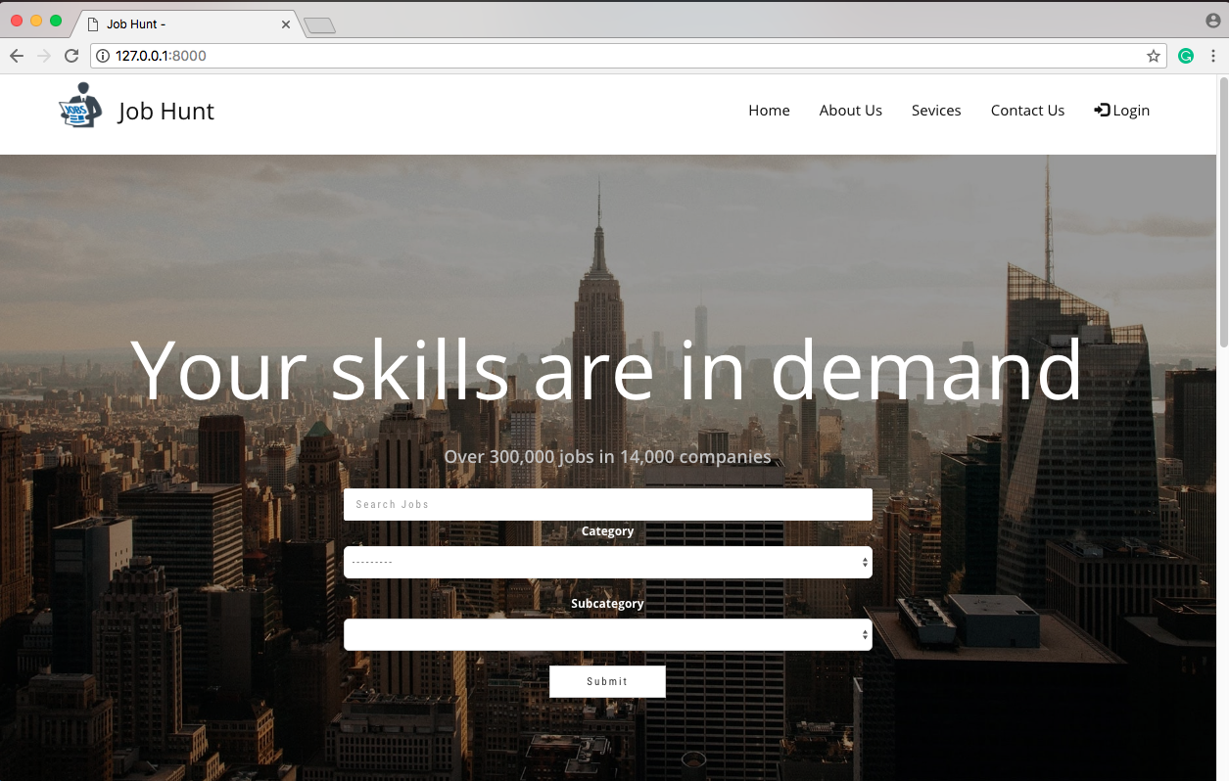

Figure . Home Page(top)

This is the default homepage which is visible to all users accessing our portal without authentication and is also the same for the authenticated Jobseekers. From here the Jobseeker will be able to search for the “jobs” by typing keywords or by selecting their preferred field category and subcategory.

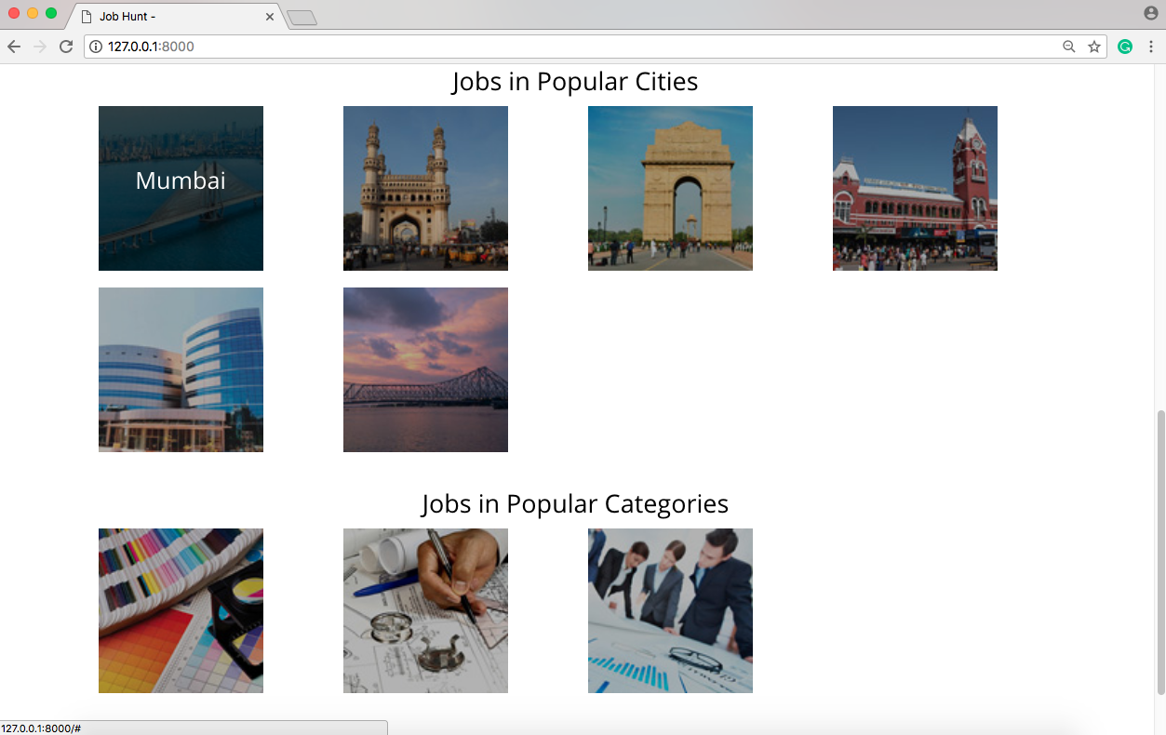

Figure . Home Page(bottom)

This is the bottom of the homepage where you can access the jobs available in the popular cities and in popular fields of work by clicking on thumbnails.

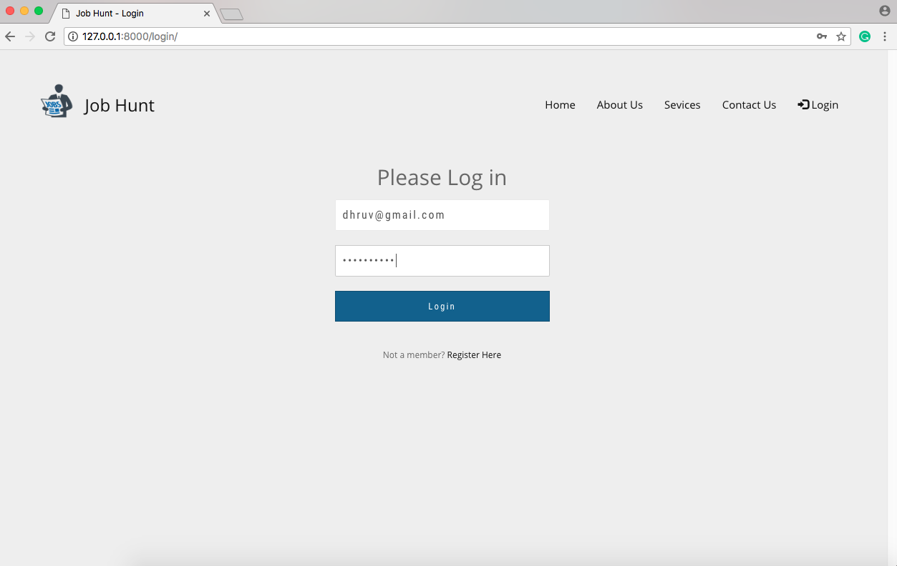

Figure . Login Page

The is the simple login page of our portal where the registered users can authenticate and log in themselves. Here the user will be automatically recognized as Jobseeker or Employer and assigned the same role as they have registered with and will have access to features accordingly.

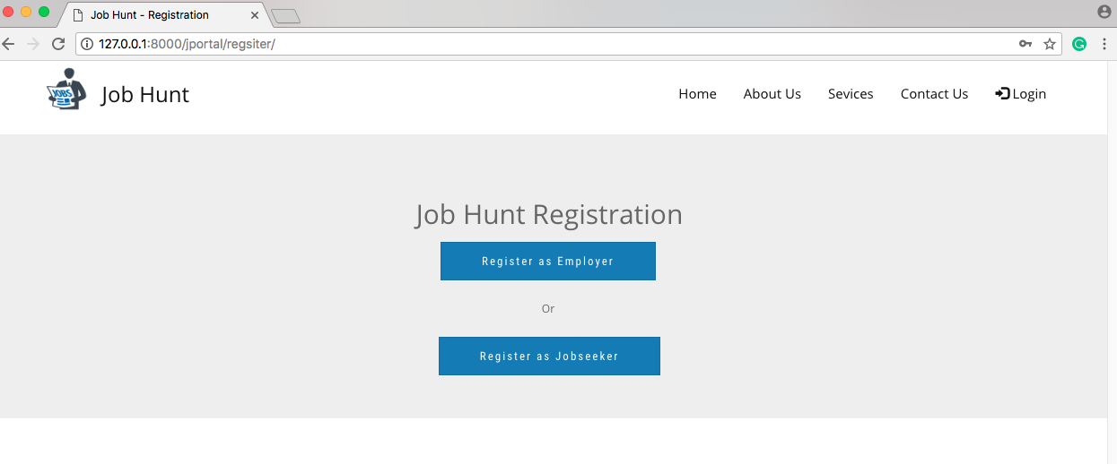

Figure . Registration Page

There can be two types of users for our website, an employer or a jobseeker. The user can choose to register as an “Employer” or a “Jobseeker” according to what they are.

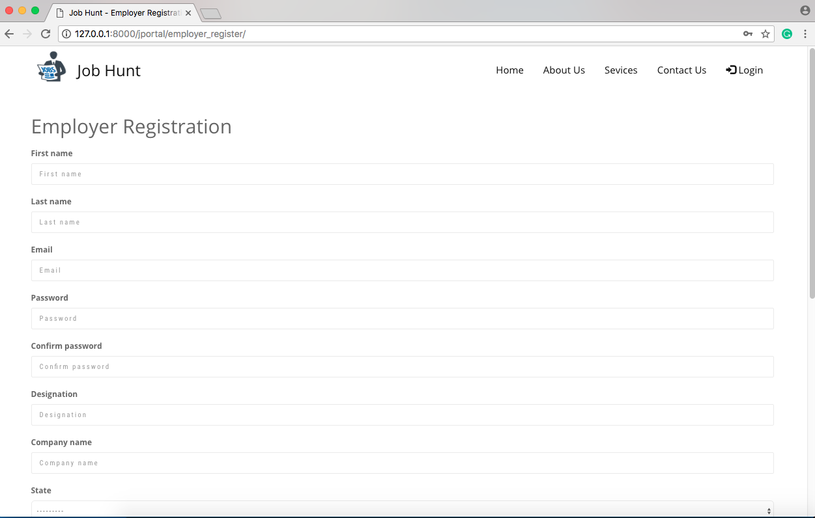

Figure .5 Regsitration Form

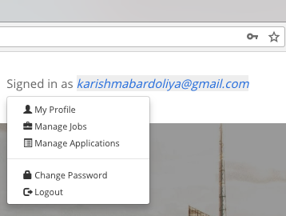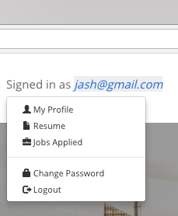The simple registration form which asks for the basic details required to authenticate the user. Here after succssfull registration, the user will be automatically logged in but they still need to verify their email in order to be verified user and access full features.

Figure . Employer’s Dropdown Menu

Figure . Employer’s Dropdown Menu

Figure .7 Jobseeker’s Dropdown Menu

Figure . Jobseeker’s Dropdown Menu

After login as jobseeker or an employer the dropdown menu in homepage will be according to the user’s role as shown in above figure.

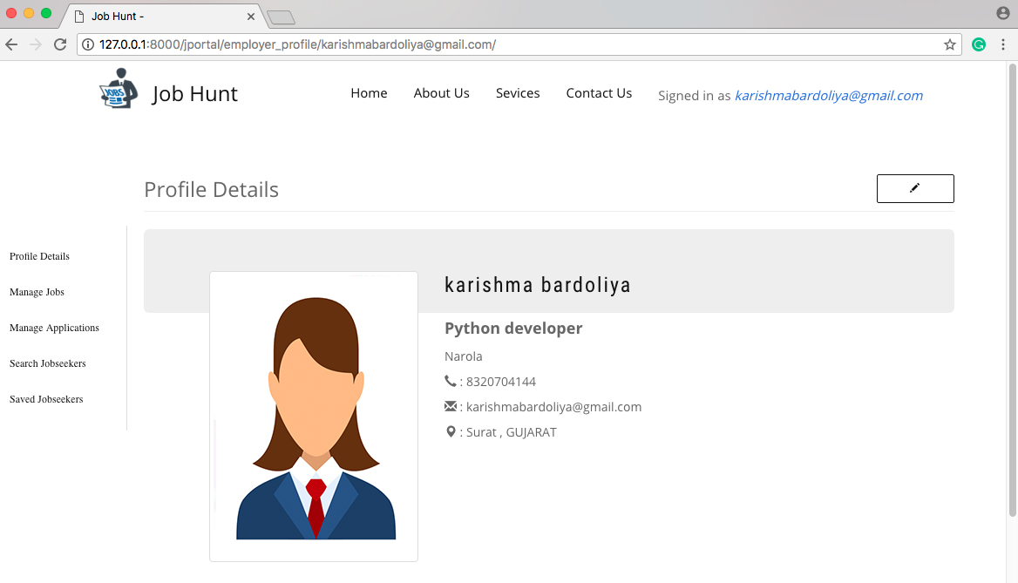

Figure . Employer’s Profile Page

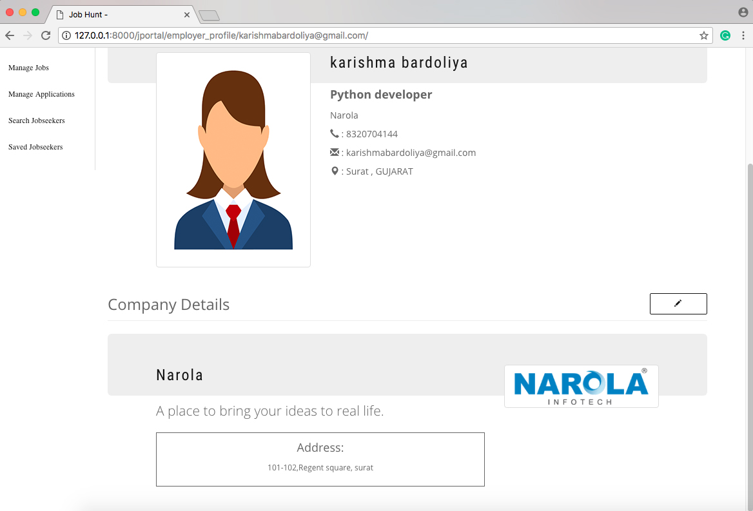

Figure . Employer’s Company Profile

On the employer profile page the basic details about employer which the user gave while registration are displayed. The empoyer can also add his/her company details to highlight himself and to make a strong impression to attract candidates.

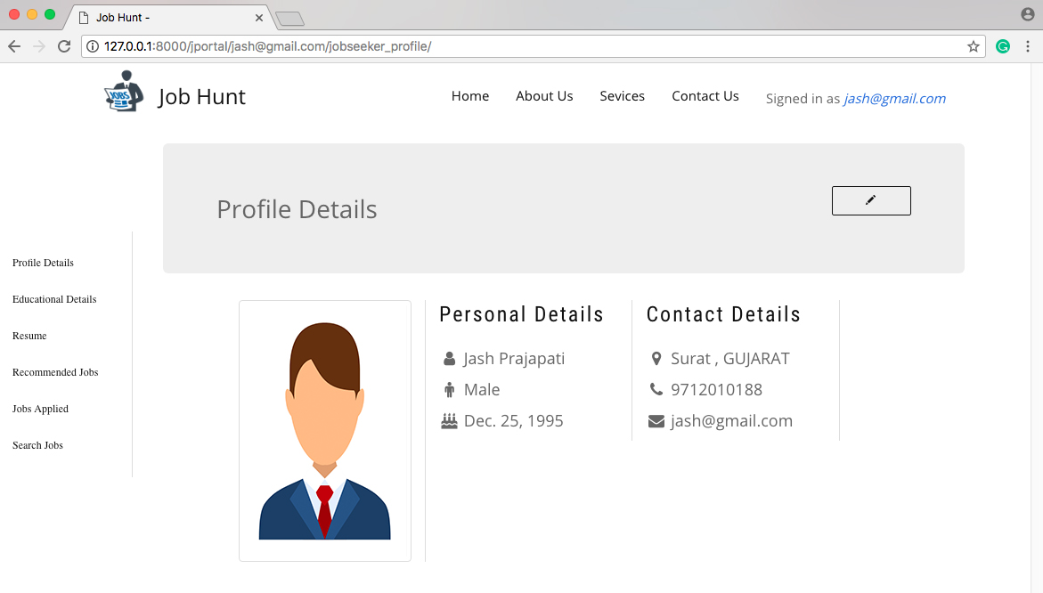

Figure . Jobseeker’s Profile Page

On the jobseeker profile page the basic details about jobseeker which the user gave while registration are displayed, which will be visible to employers when viewing their profile.

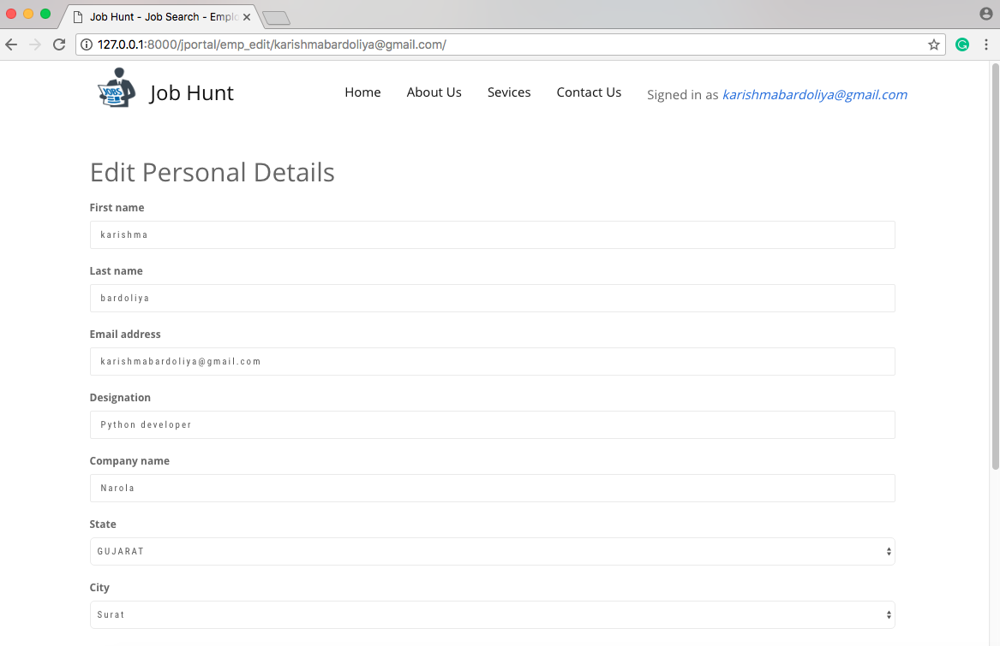

Figure . Edit Profile Details Page

Add, updatation of details is also possible from profile page for both jobseeker and employer.

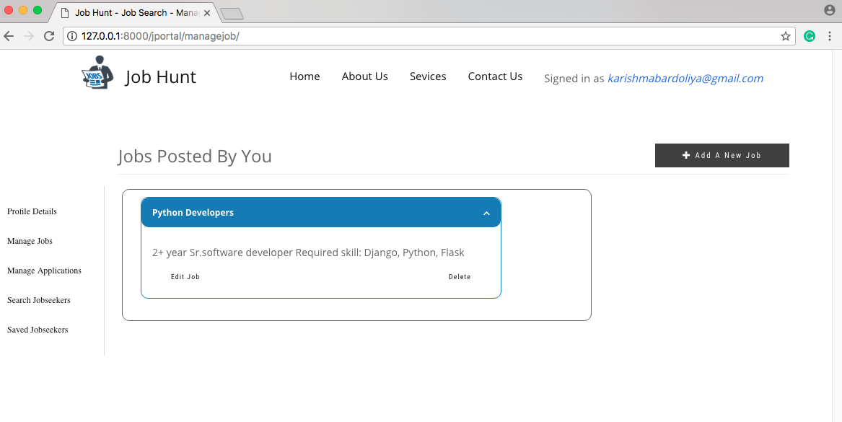

Figure . Manage Job Page (for employer)

The manage jobs section is for the employers, where they can see their various jobs posted by them and can also view, edit or delete the details as per their need. From here only the employers have the option to add a new job upon clicking on the button “Add New Job”.

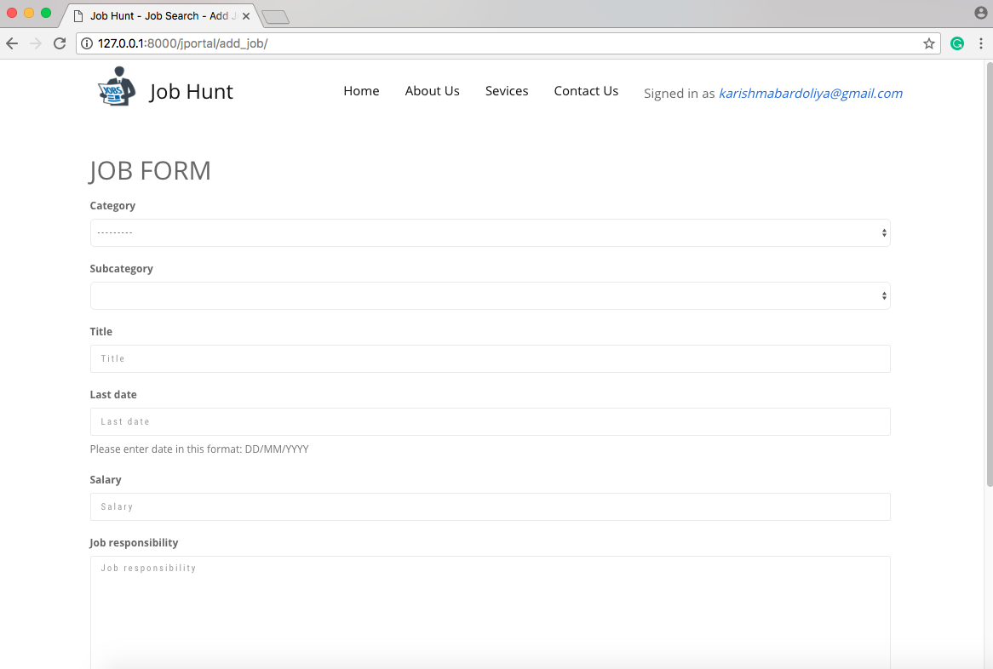

Figure . New Job Posting Form

The employer while adding a new job, he/she have to fille up details like job description, title, add job’s category and subcategory, salary and job responsibility.

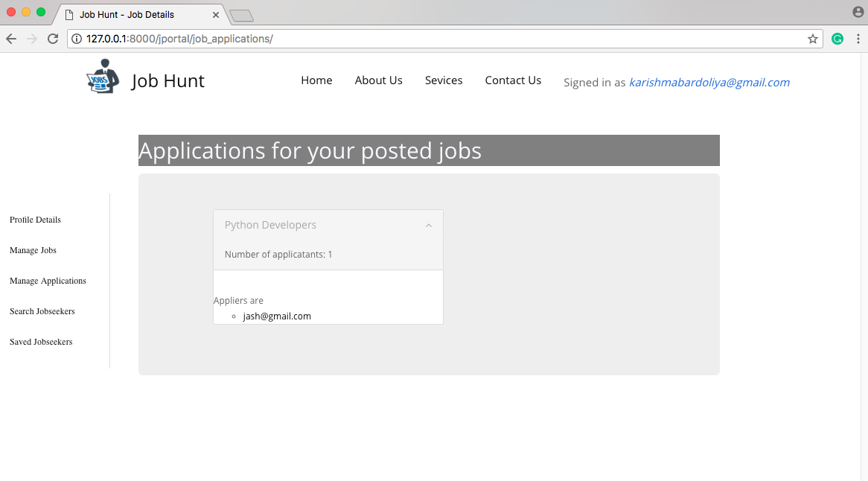

Figure . Job Applications Page (for employers)

In the job application section the employer can see the list of jobseekers who have aaplied for the each jobs they have posted and the number of applicants for the same. Then they can view their profile from there upon.

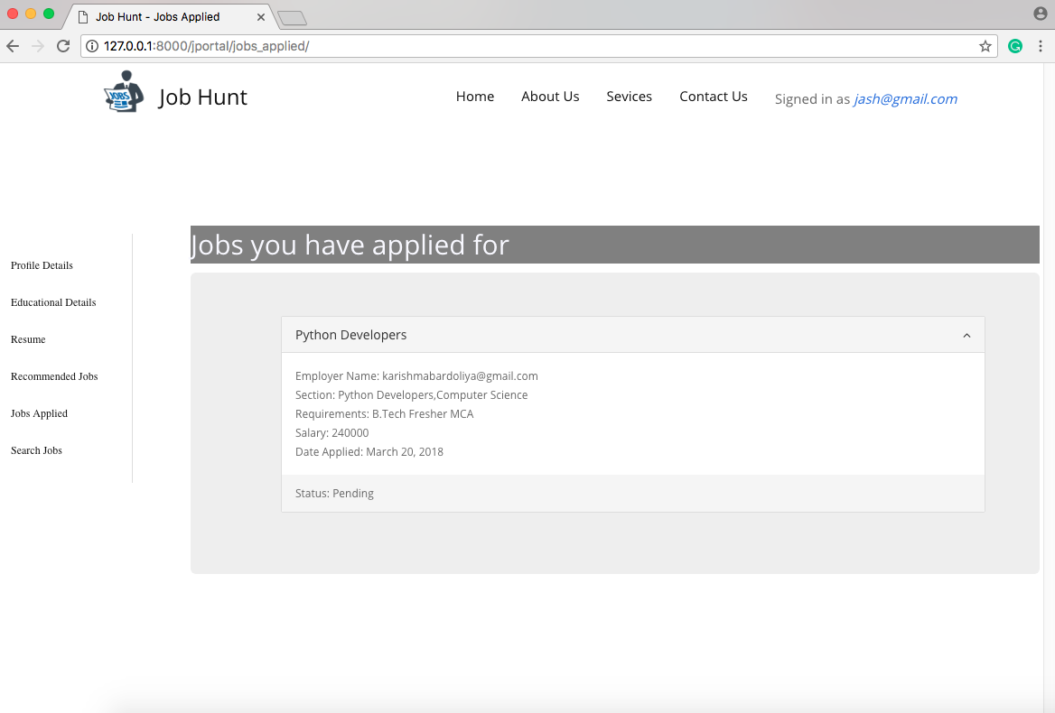

Figure . Jobs Applied Page (for Jobseeker)

The jobs applied section is for job seekers, where they will be able to keep track of jobs they have applied on and the status for their approval.

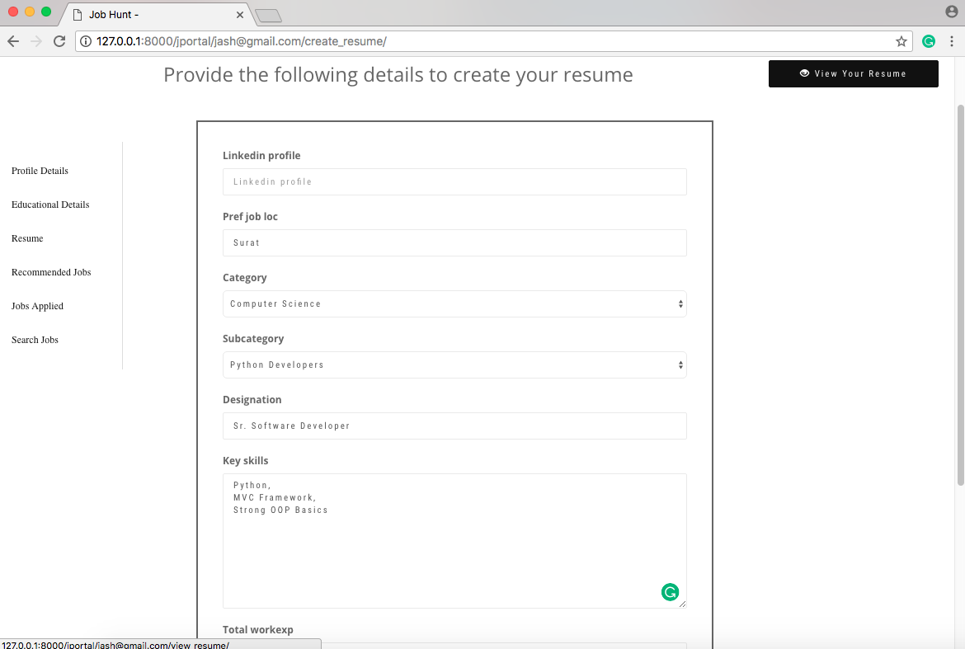

Figure . Jobseeker’s Resume Page

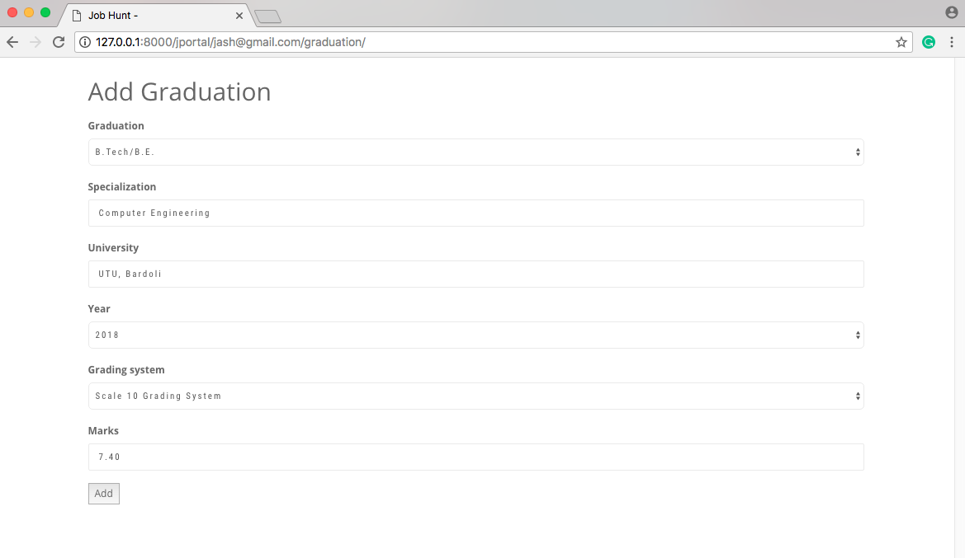

Figure . Education Details Page (for Jobseeker)

The jobseeker in the “resume” section can add their details for their resume or can simple upload their resume file if they have one. They can add the details about their education i.e. Graduation, Post Graduation, School, Specialization which will be visible on their profile page.

## Test Cases

Table . Test Cases

|  |  |  |  |  |  |
| --- | --- | --- | --- | --- | --- |
| **Test ID** | **Case** | **Test Data** | **Expected Result** | **Actual Result** | **Pass/Fail** |
| 1 | Login | * Internet connectivity * Email * Password | If email & password is empty or invalid and no internet connectivity then display error message otherwise login successfully, deciding user roles. | If email & password is empty or invalid and no internet connectivity then display errror message otherwise login successfully, deciding user roles. | Pass |
| **2** | Job Search | * Keyword * Category * Subcategory | User should be able to get the list of jobs by typing in the keyword or by selecting category and subcategory. | The search results are collected and are shown below the search bar according to the user input. | Pass |
| **3** | Post Job | * Job information | Job should be added according to the category and subcategory. | Jobs are added category & subcategory wise. | Pass |
| **4** | Apply for job | * User as Jobseeker * Job ID | Only the authenticated Jobseeker should be able to apply for the job otherwise he/she will be redirected to the login page. | Job application is successful for authenticated jobseekers and unauthenticated are not allowed to apply before logging in. | Pass |
| **5** | Approve/ Reject Application | Employer will   * approve or * reject   the application | Only the registered employer can view, approve or reject the application and only for jobs posted by himself. | Only the employers of the posted job are able to view, approve or reject applications and none other | Pass |
| **6** | Search Jobseeker | * category/ subcategory * state/ city wise | Employer should be able to search for jobseekers with either state/city wise or category/subcategory wise and see the list of them as a result. | Employer is able to search with either category or state/city and the profile of the jobseekers are shown accordingly. | Pass |
| **7** | Logout | * select logout | User should be logged out of the portal and be redirected to the Homepage | User get logged out of their account and are redirected to the Homepage. | Pass |

# Conclusion and Future Scope

Job matchmaking is an important issue in today’s global, distributed and heterogeneous market. We have briefly explored how available technology can possibly help how job recruitment and job seeking processes are implemented. We strongly believe that, due to its high social impact, research has to look with “Job Matchmaking” not only with goal to purpose advances in the scientific knowledge, but because this is an application area capable of bringing direct and immediate benefits to humanity. Here, we have designed a project “Online Job Portal” using Django Framework. All the application codes are in Python3. This portal provides all the features. Our project satisfies all the functional requirements mentioned in the project, however, it doesn’t have chat application module which allows employers and jobseekers to have one-to-one communicaton in this portal. In future we will add some features in this portal with some other variation like the above mentioned chat application and pro-users functionality. Also we would like to design more user friendly portal system.

References

**Web references**

1. [Online] https://docs.djangoproject.com/en/1.11/ [Date Accessed: 10 JAN 2018].
2. [Online] https://simpleisbetterthancomplex.com/tutorial/2016/07/22/how-to-extend-django-user-model.html [Date Accessed: 10 JAN 2018].
3. [Online] https://djangoforbeginners.com/blog-with-forms/ [Date Accessed: 15 JAN 2018].
4. [Online] https://medium.com/@adriennedomingus/working-in-forms-with-django/ [Date Accessed: 23 JAN 2018].
5. [Online] http://getbootstrap.com/docs/3.3/getting-started/ [Date Accessed: 3 FEB 2018].
6. [Online] https://github.com/dyve/django-bootstrap-toolkit [Date Accessed: 5 FEB 2018].
7. [Online] http://django-simple-captcha.readthedocs.io/en/latest/usage.html [Date Accessed: 16 FEB 2018].
8. [Online] https://github.com/PragmaticMates/django-clever-selects [Date Accessed: 23 FEB 2018].